ActiveLearn: iPad Login Issues
This guidance may help resolve login issues on iPads for ActiveLearn and ActiveLearn Primary.
20-Nov-2020•Knowledge
Issue
You cannot log in to ActiveLearn or ActiveLearn Primary on your iPad, and see a loading icon (such as a colourful circle) or an error message like the one below:
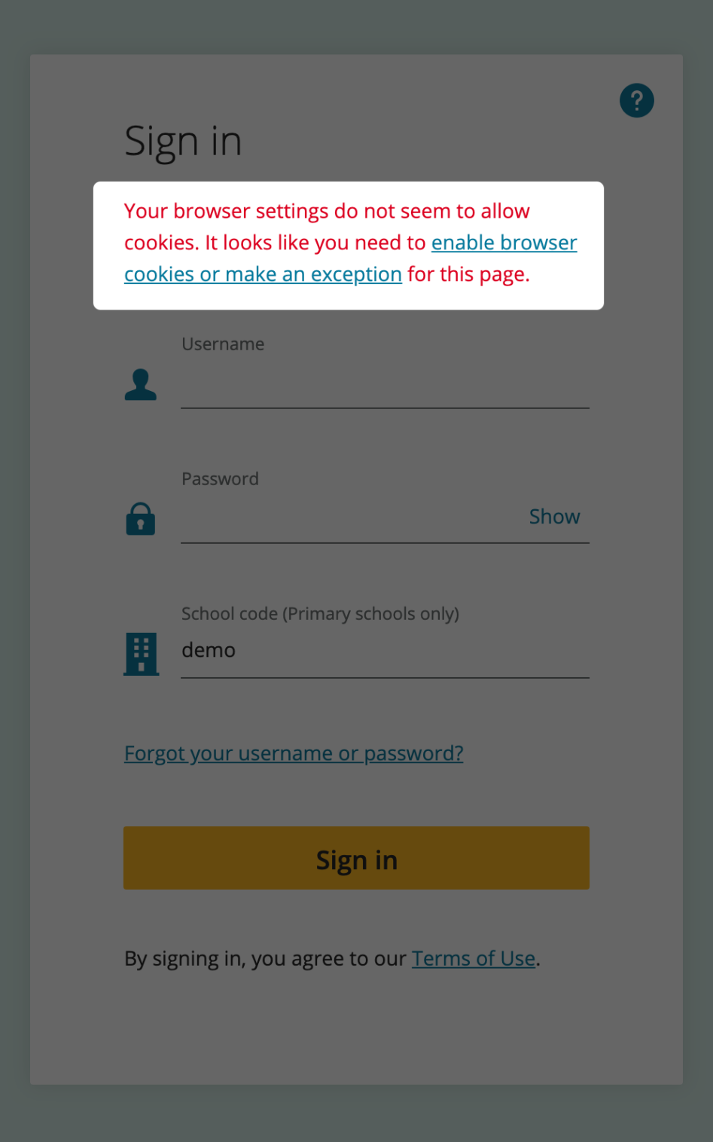

Please follow the below troubleshooting steps to try to work through issues when logging into ActiveLearn on your iPad.

Detailed Instructions

Update your version of iPadOS
The first step we recommend is making sure you are using the latest version of iPadOS. At the time of writing, we recommend iPadOS 13.3 or newer, as this can help make sure that any relevant bugs in Safari have been fixed.

Allow cookies in Safari
Within Settings, find the section for Safari, and toggle the control labelled "Block All Cookies" so that it is off.
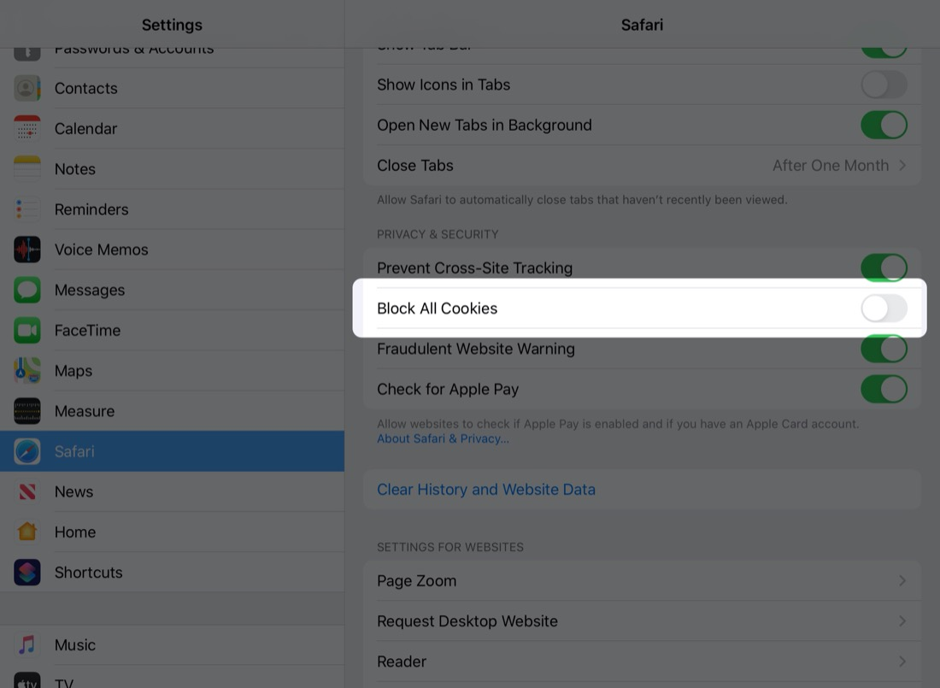

More on this topic: ActiveLearn Primary: Allow Third Party Cookies

Allow Cross-Site Tracking
Although you may be able to log in even though you are seeing an error message, turning off the setting for Prevent Cross-Site Tracking and refreshing the login page in Safari will help to dismiss the error message entirely. If you are unable to log in at all, it may help with that issue as well.

Good to Know
This step may also be helpful for Safari on Mac, where this setting can be found in Preferences > Privacy.

Clear your browser cache
If the issue persists, you may need to clear your stored website data. This can be done from Settings > Safari, from the Advanced section. Under the Website Data list, swipe to delete the entries for pearsoned.com and activelearnprimary.co.uk
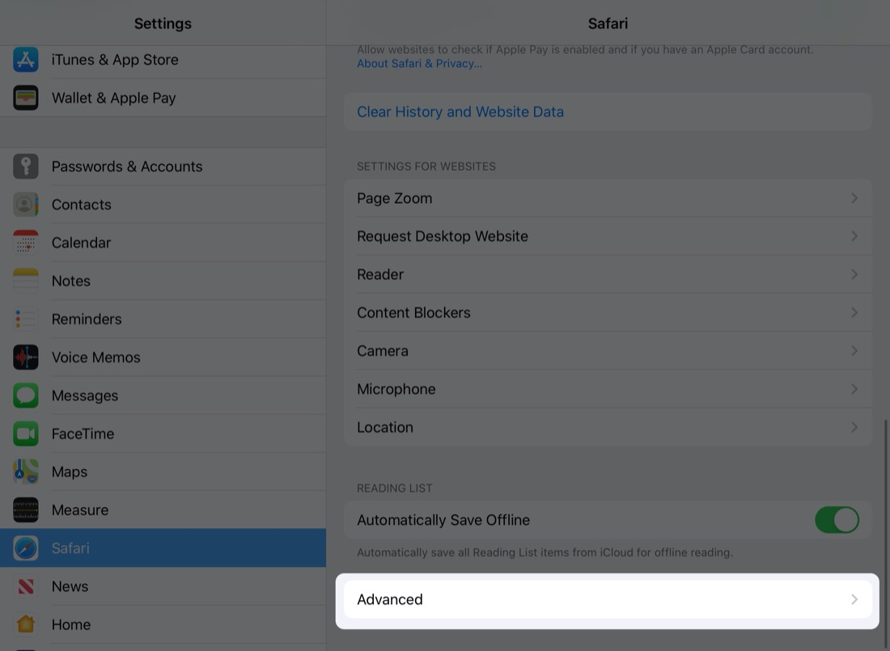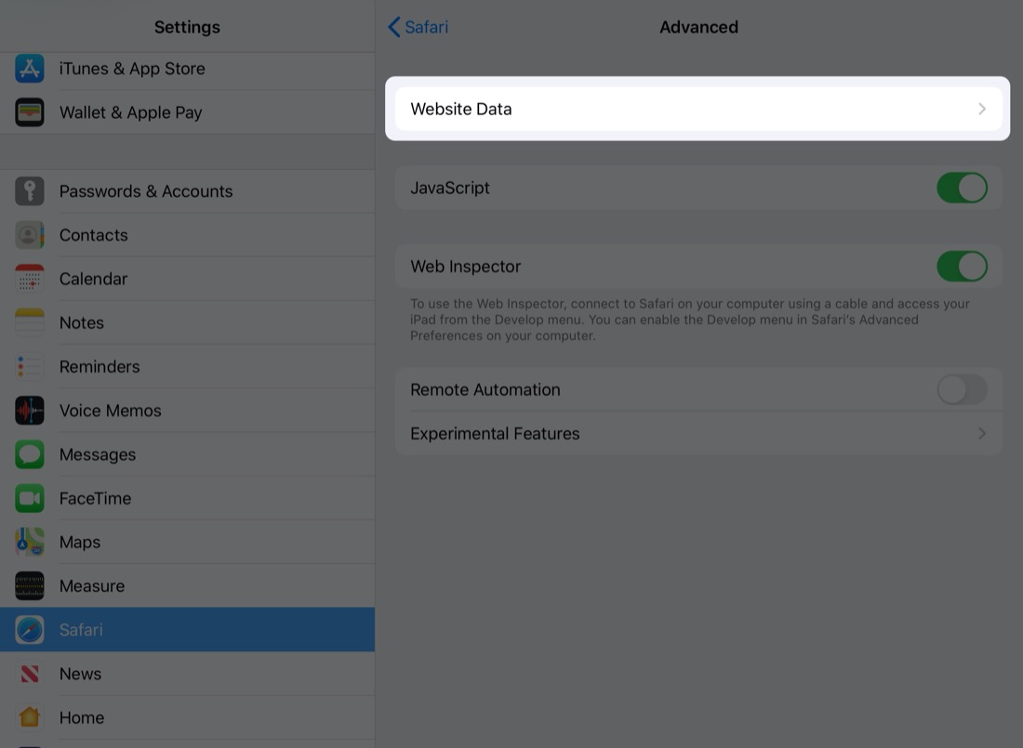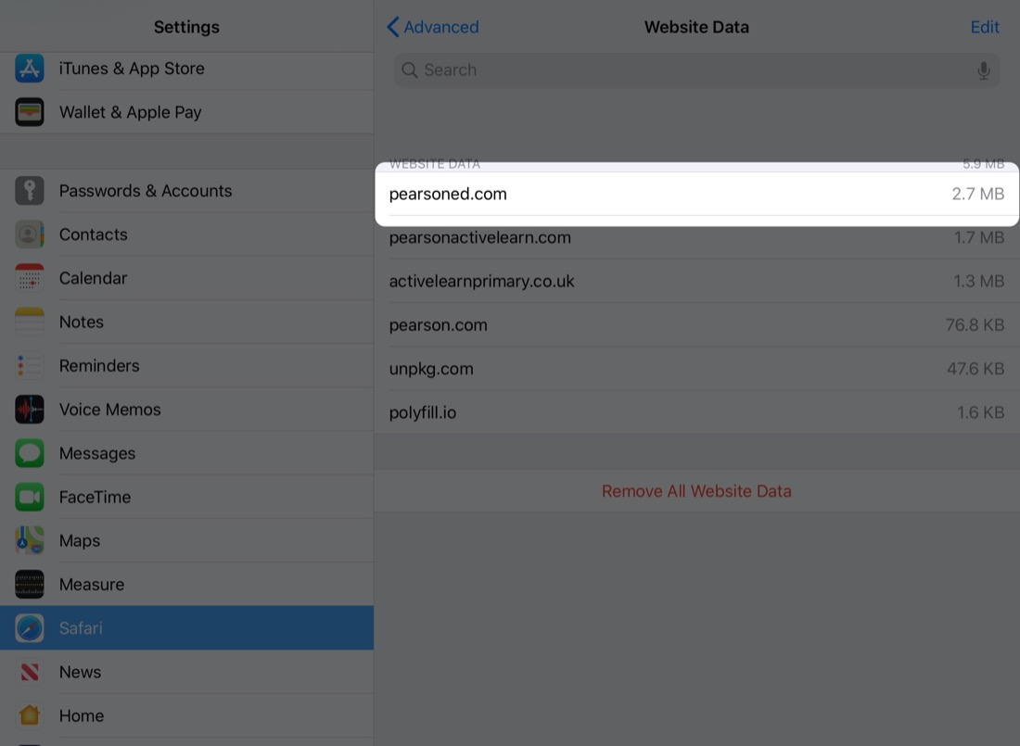

Make sure ActiveLearn is fully allowed on your network
Another step to try is to make sure all parts of Activelearn Primary are allowed on your network. To test this, we advise trying to load/log in to ActiveLearn Primary through a different internet connection, such as mobile data or home WiFi.

