Enderby ROAD InfANTS School

Headteacher’s News Letter
Friday 23rd October 2020

Hello Yellow Mental Health day
Well done we raised £30
for The Young Minds Charity

Dates for diaries
2nd Nov: School opens for Autumn term 2
13th Nov: Children in Need day (more info to follow)
Christmas calendar dates to follow after half term

Harvest Scarecrows!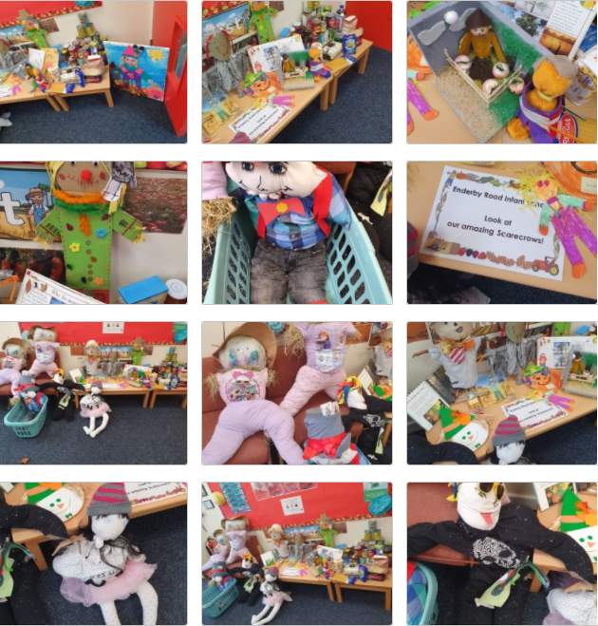Well done to all the children who brought in their home-made scarecrows! We were blown away by your creativity! All children who took part received a small prize. Thank you for our harvest donations these will be collected by members of the Scunthorpe Baptist Church foodbank today.

Harvest activities this week!
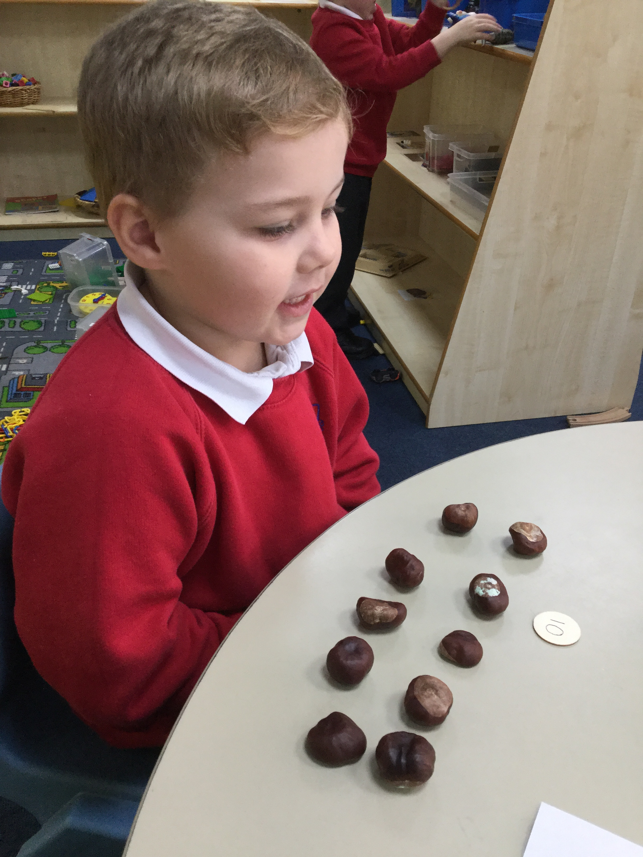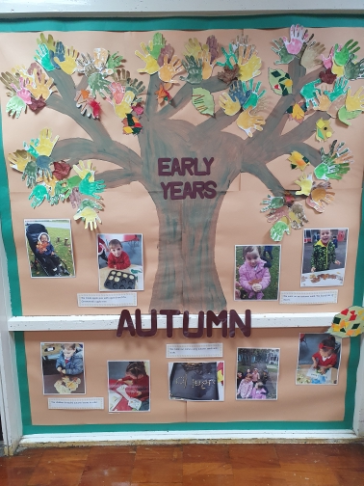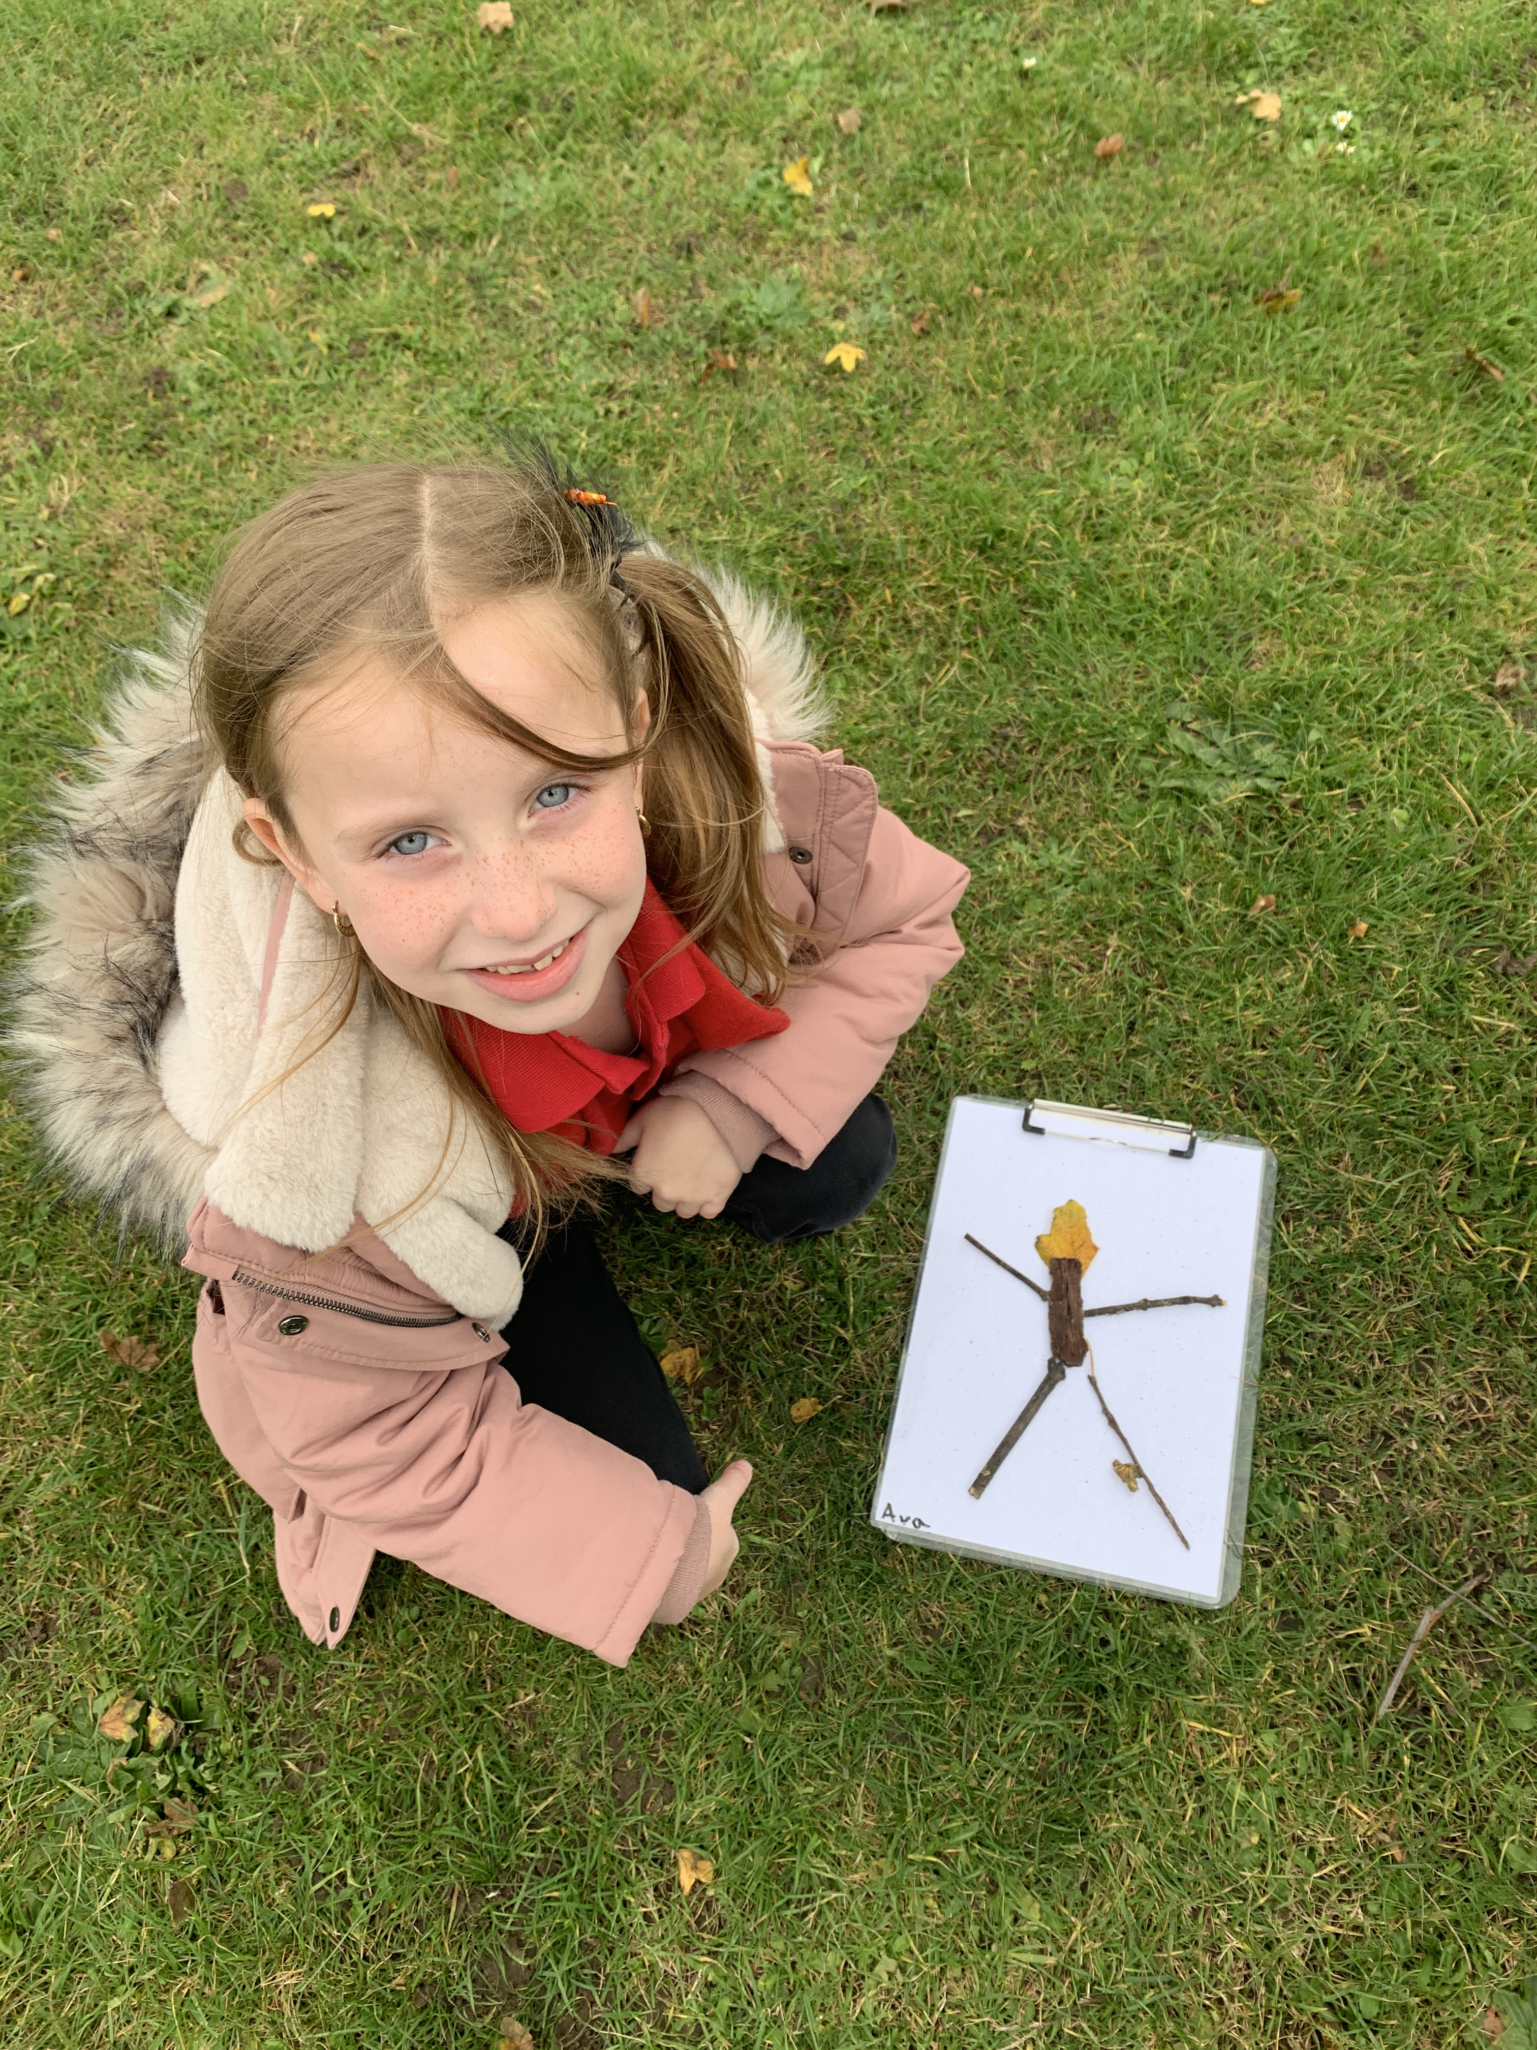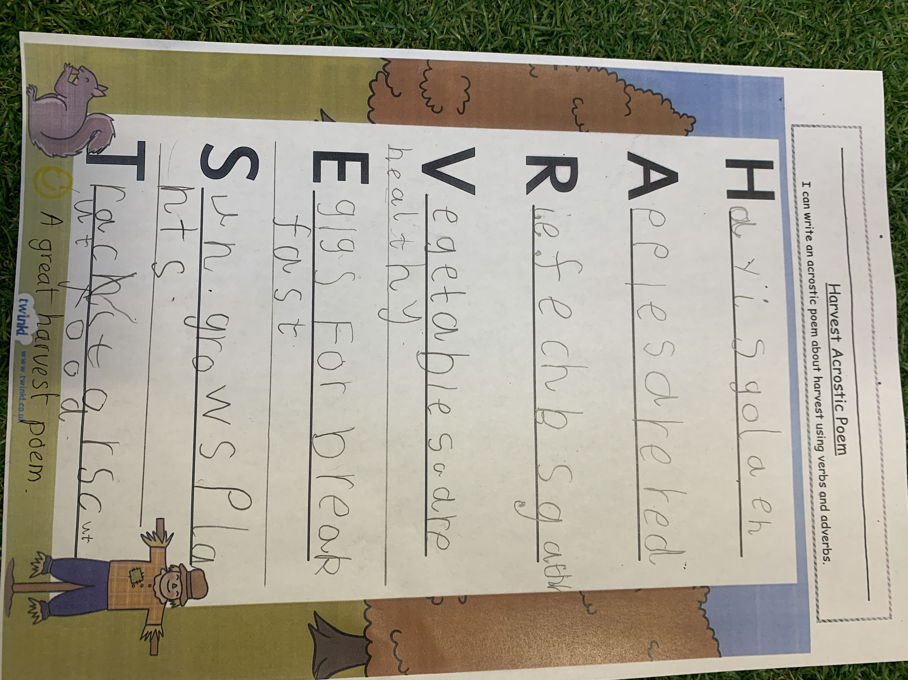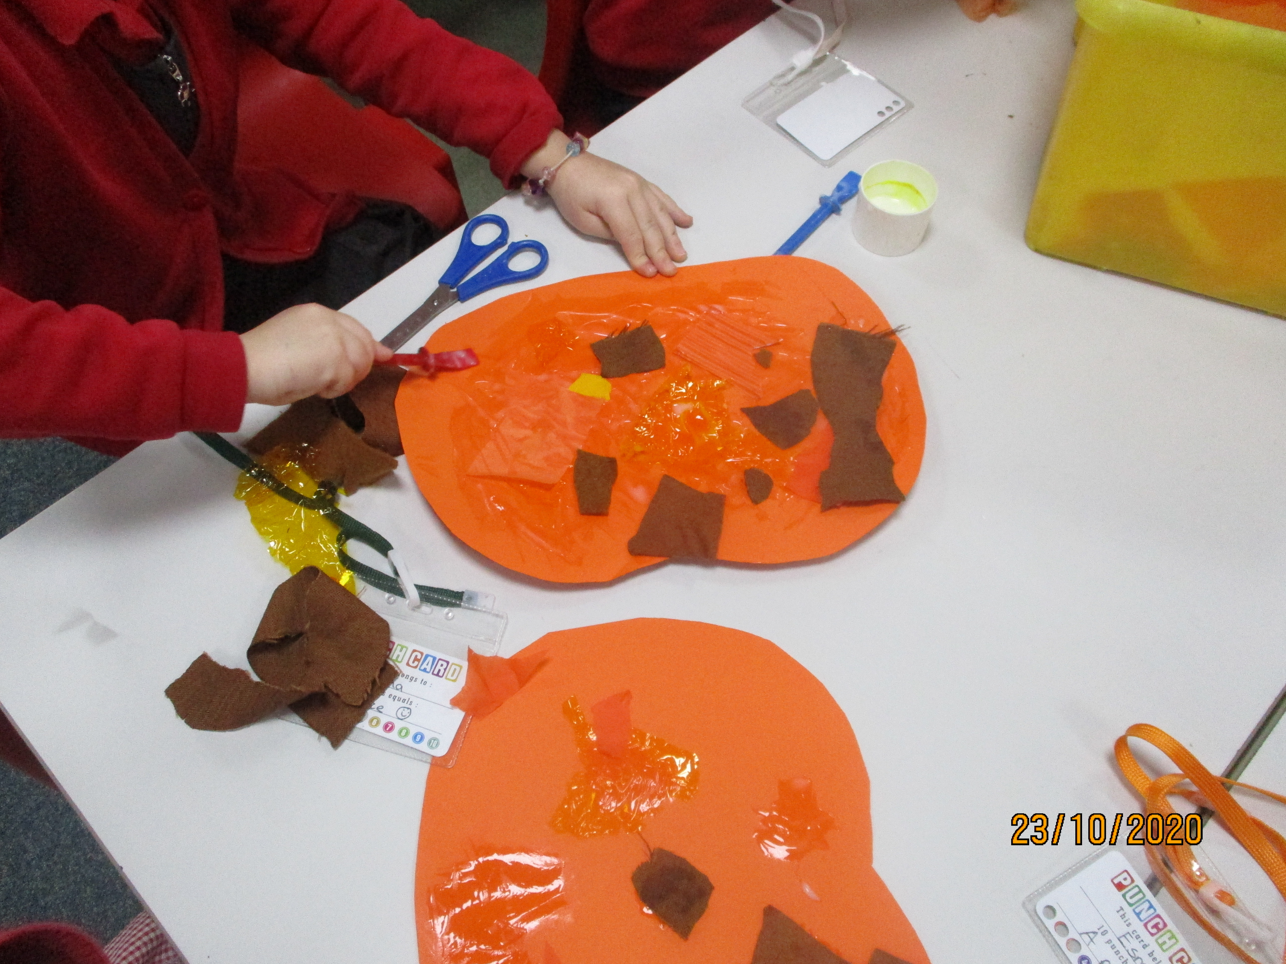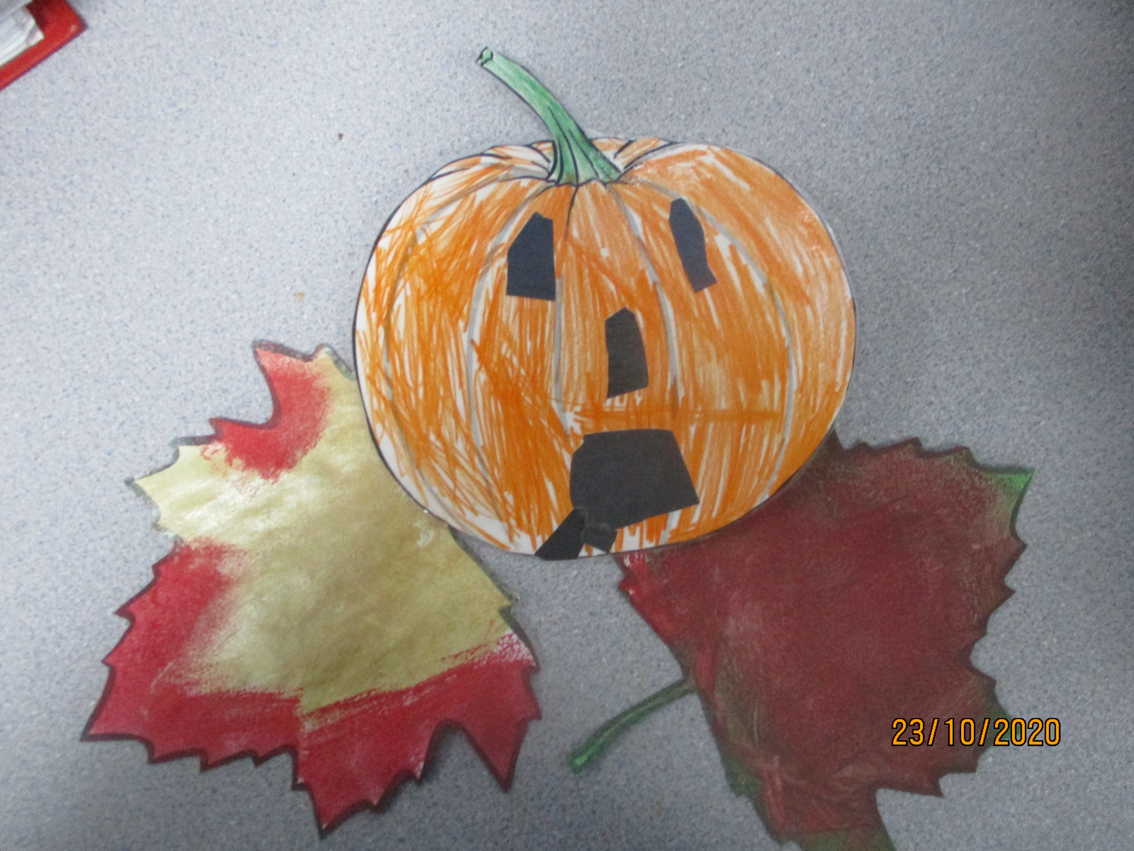

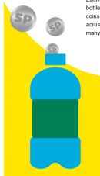

Parent Mail-Pay Plus coming soon!
Look out for a letter regarding our new payment system.

Dear Parents / Carers,
It’s hard to believe that we are at the end of this half term – it feels like only seconds ago that we welcomed all of our lovely children back to school.
The children at Enderby Road have been absolutely brilliant this term at adhering to the school rules related to Covid, getting to grips with working incredibly hard in class, whilst sanitising their hands like professionals! I am so very proud of them.
I would like to extend a heartfelt thank you to you all, for your amazing cooperation with this way of working. Waiting with your children before school, minimising visits to the site (including the office) is all helping the fight against COVID, so, thank you.

5p challenge
After half-term we will launch our 5p challenge. All of the classes will take part in a race to fill a 2 litre bottle with 5 pences. The classes will get a class treat once their bottles are filled! The money raised from the 5ps will all go towards school funded projects. A bottle has been placed in each class for pupils to add their 5p coins. I will check the bottles every few weeks to give everyone an update on how the classes are doing and who might be in the lead. So please raid your money boxes, save your change, look down the back of the sofa and join us to help us
raise funds for the school!

Achievement Tree
At school we want all children to take pride in their
achievements, not only in school but outside of school too.
To help us celebrate these special moments we would like to ask for photographs or certificates showing our children’s excellent endeavour outside of school. These will be placed on our achievement tree. You can email photos and certificates to school or send them with your child for us to photocopy. We want to share in celebrating things like your child learning to ride a bike, swimming or taking part in any clubs or special events and competitions.

Autumn is now in full swing, so please do have a wonderful half term with your children, taking time to collect conkers and just enjoying the beautiful colours that this season brings.
We look forward to a safe and happy return to school on Monday 2nd November.

Kind regards
Mrs Goulthorpe

