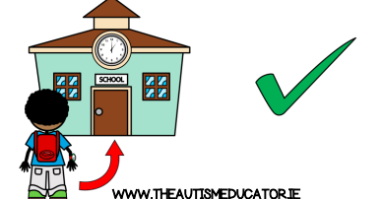


A parent’s guide to school reopening
Enderby Road Infants School- September 3rd 2020
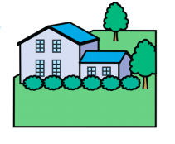
When will my child attend? All children will return to school on Thursday September 3rd 2020. Children in Reception, however, will be given a phased return (more info to follow from Mrs Greenwood).
To aid us with social distancing, staggered start and finish times will be introduced until further notice.
· Class 1 and Class 2: 9am-3.15pm (use the back gates)
· Class 3: 8.55-3.15pm- class 3 door
· Class 4: 8.45-3.05pm- class 4 door
· Class 5: 8.55-3.15pm- main entrance
Please drop off and collect your child from the designated external classroom doors shown above but please don’t worry as members of staff will be present during the first week to guide you to the relevant drop off and collection points. There will also be signs for you to follow. Please limit drop off and collection to 1 adult and we kindly ask you are prompt to arrive and leave with your child at the end of the day. We ask that parents do not gather in groups on the school grounds.
Regrettably parents won’t be allowed inside school. You will need to socially distance when dropping off and collecting using the markers we have put in place.
Who can come?
All children are expected to return to school unless they are unwell. Our usual attendance systems will resume. We ask you contact us via a phone call or by email by 9.30am on the day your child is unwell to inform us.
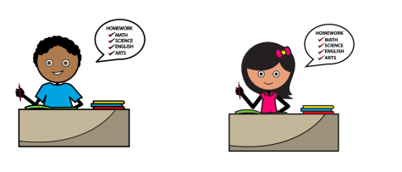
How will you socially distance?
Children will be put into whole class ‘bubbles’. They will always use the same class room and will have break times with their class only; they will not mix with other classes. They will eat lunch in their classroom. Lunch will consist of a ‘Grab Bag’ to start with which is a healthy meal made up of hot or cold food (the menu will be available on our website). As part of universal free school meals children will be able to have a free school lunch. Nursery children should bring their own packed lunch. For Nursery there will also be the option to pay for a packed lunch if required. Vouchers will not continue for Free School meals. Each room will have the same teacher. In classes each child will be given a specific area to sit at and separate stationery, which only they will use. Staff will clean surfaces and resources throughout the day. Children will wash their hands many times during the school day. We have allocated toilets to groups so there will be minimal mixing. We are however conscious that very small children will find it almost impossible to stay apart all day.
What will the children be doing in school?
We have guidelines as to what we can allow children to do whilst in school. There will be no assemblies and whole school events. All children will be able to have playtimes as a class. We can let them share sports equipment and everything will be thoroughly cleaned after use. Children will need to bring their own named water bottle with water and book bag. Children are expected to wear their school uniform and will require their PE kit.
Teachers and support staff will continue to teach high quality lessons. There will be a focus on additional Reading and Phonics too. We will of course continue to provide a wide range of cross-curricular learning opportunities to engage, excite and motivate our children.
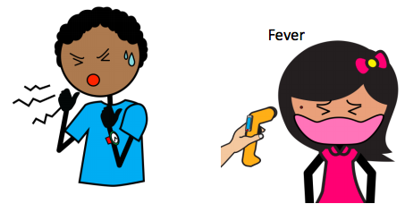
What if someone becomes ill?
It will be your responsibility as a parent to make sure your child is well enough to come to school. We will not be taking temperatures during the school day as this is not recommended. If a child becomes ill, they will be moved to a room with one member of staff, who will wear PPE at that time. We will contact you and an ambulance if they are seriously unwell. If your child falls, staff will obviously help them. If they need to wear PPE, they will. If someone becomes ill with COVID-19, we’ll follow the advice on the government website and inform you accordingly. The government advice is that school staff members do not wear masks, nor do children. We will have PPE available for the staff should they need it.

We are here for you and your child
We will be continuing to use our website to update information and parent mail to contact you. Please ensure we have up to date records of your contact numbers, home addresses and emails addresses as we will be using these methods to keep you well informed. We ask parents email us or call us if they have any questions.
We are working hard to make sure plans for pupils to ‘catch up’ are in place. Support will be put in place when we re-open to narrow gaps and we will be adapting our curriculum to suit. Your teachers are experts at identifying and plugging gaps so this will not be a problem.
We have missed the children and we cannot wait to see them all in September!

