
Enderby Road Infant School
Mrs N Goulthorpe
Headteacher
Sunningdale Road
Scunthorpe DN17 2TD
Telephone Scunthorpe (01724) 861571
email admin.enderbyroad@northlincs.gov.uk

Dear parents/carers
I do hope you have been keeping safe and well.
Following the Government announcement last Thursday we are delighted to be welcoming all of our children back to school from Thursday 3rd September. School has not been school without the children and we simply cannot wait to have them back with us! Although I have met many of the children and their parents I am really looking forward to putting names to faces, as I have heard so many wonderful things about the children. I am determined to get school up and running and I want to say a big thank you to all our families for being supportive and patient during this challenging time.
The anxiety that some children, families and staff will feel about a full reopening in September is still a concern however I want to reassure you we are working hard to make sure we are well prepared. We have to be aware that the school cannot be exactly the same as it was before. We are going to have to limit opportunities for children to mix with each other and avoid mass gatherings. Assemblies and whole school events may well not take place for some time and we have also taken the decision not to run any after school enrichment clubs for the first term. The focus of our efforts will be very much based on providing full support for our children both in terms of mental health & well-being and of course academically.
Plans for September opening
School opens for the new academic year on Thursday September 3rd and ALL children will be expected to return. There will however be a phased for our Reception children.
In preparation for Thursday 3rd September please can you make a note of the following:
- All children should be dropped off and collected from the designated external doors. The staggered start and finish times will help social distancing. Members of staff will be present on the first few days to guide you to the relevant entry and exit points. There will also be signs and markers for you to follow.

Start and finish times

Class 1 and Class 2: 9am-3.15pm (use the back gates)

Class 3: 8.55-3.15pm- class 3 door

Class 4: 8.45-3.05pm- class 5 door

Class 5: 8.55-3.15pm- main entrance

- Please adhere to the markers when dropping and collecting your child and please be prompt to arrive and collect. We politely ask parents to not gather in groups on the playground.
- Parent/carers will not be permitted to come into the school building so we ask you email or phone school should you need to speak with the teacher and they will contact you. If you need to speak directly with the teacher at the end of the day please wait until all the children are released first.
- All children should wear uniform and should bring their own named water bottle. A PE kit and a book bag are also required.
- Lunches will be provided by school unless you wish to provide your own.

I would like to reassure you that the measures we have put in place are there to minimise potential risk. Our detailed risk assessment document, which will soon be found on our website, outlines how we will address the practicalities of fully opening, whilst following government guidelines.
There is also a power-point for parents and another to share with the children on our website. This provides all the information you need and should alleviate any concerns around re-opening in September.

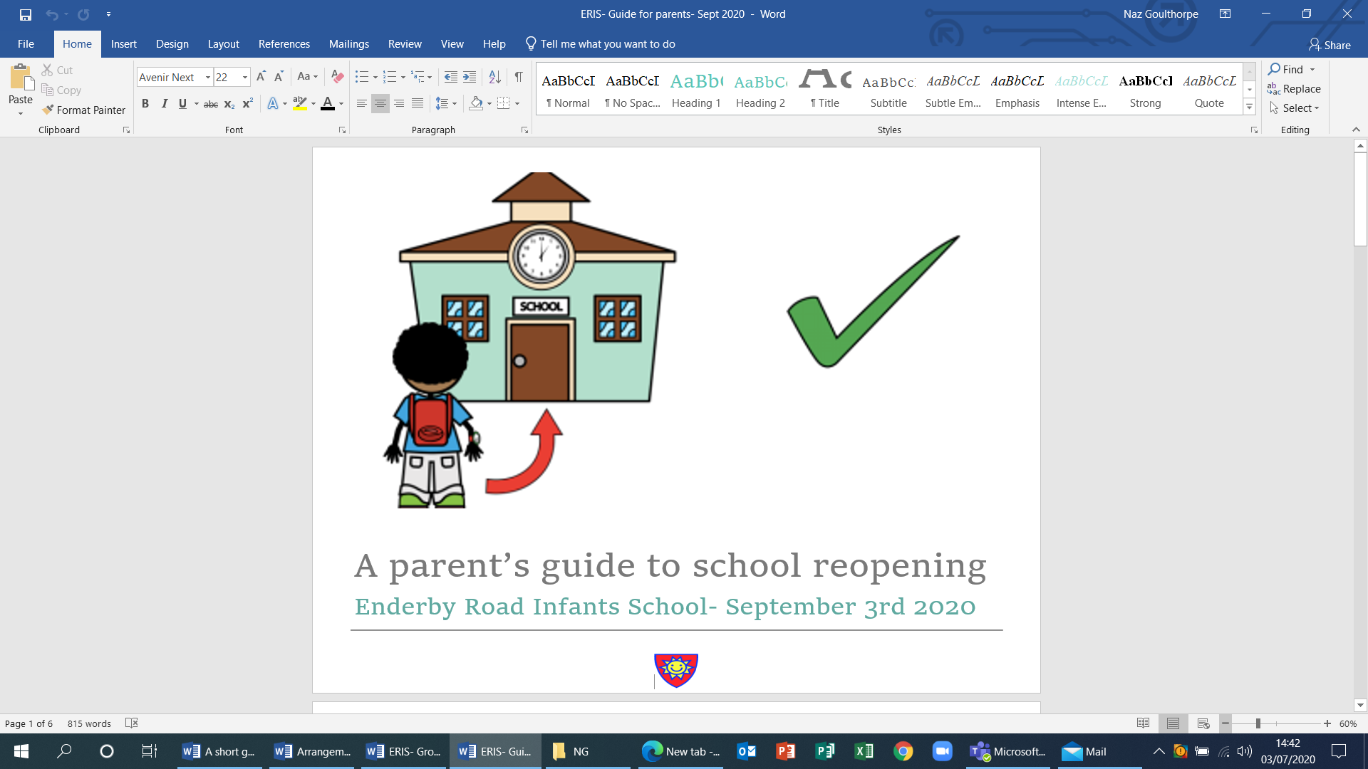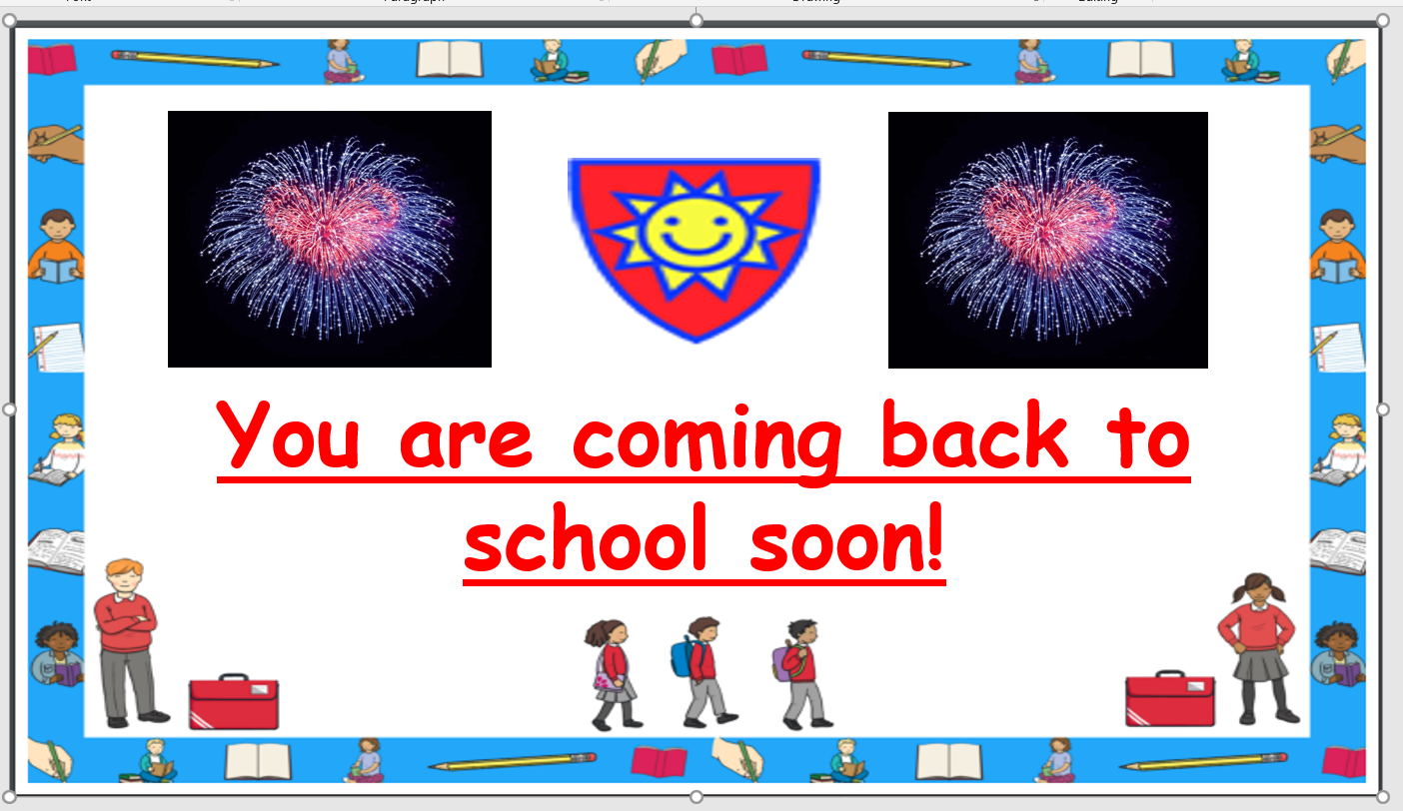

School will be closed over summer so I do urge parents to access our school website which has been continuously updated since March 20th. On this you will find a wealth of information including regular updates.
We also do need to make sure we have up to date information for all our parents so please do keep us informed of any changes to mobile numbers and email addresses. It could be the government provides us with updated information over summer which we may mean we need to notify you of any changes.
Looking around school, we still have a few items that belong to some of the children that you will want to collect before we have a summer clear out. Belongings that can be collected include jumpers, bags and inhalers. Some children will also have school reading books that will need to be returned. Please drop these in before Thursday 16th July.
Finally, please have a lovely weekend and do know that all the staff here at Enderby Road Infants are thinking of you.
Stay safe and well.
Mrs Goulthorpe

Don’t forget our meet the new teacher sessions!
Class 3- Monday 13th 1pm-2pm – Mrs Parker | Class 4- Tuesday 14th 1pm-2pm- Miss Mellows
Class 5- Tuesday 14th 10am-11am- Mrs Matthew & Mrs Smith | Class 2- Thursday 16th 10-11am- Mrs Greenwood

