End of Year Booklet
This is me in Class 3
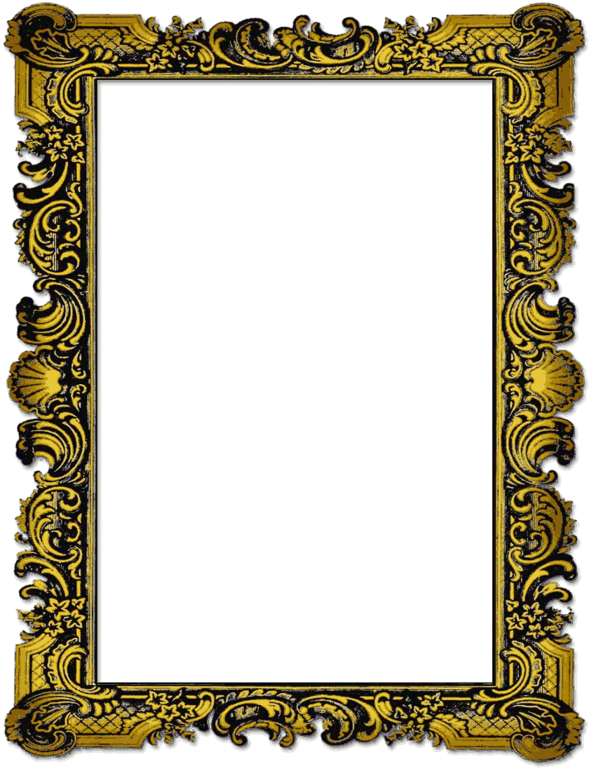

My School
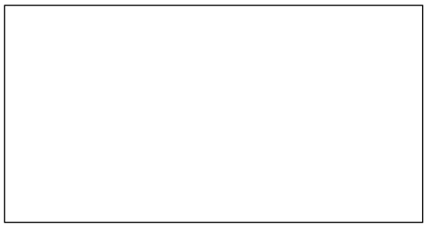

My school is called ________________________
___________________________________
It is a school for _________________________
It is in ___________________________
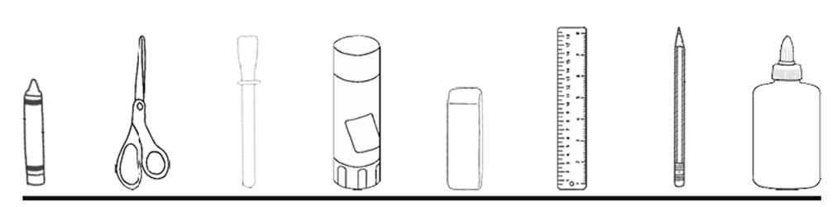
The head teacher is called ___________________

My Teacher
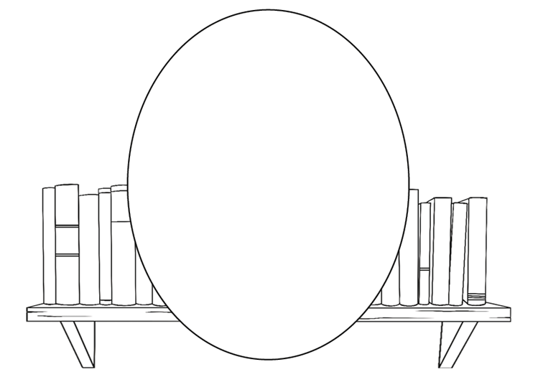

My teacher is called ___________________
I liked my teacher because ___________________
_________________________________________________________________________________________________________

My teaching assistant
My teaching assistant is called ___________________
I liked my teaching assistant because _________________________________________________________________________________________________________

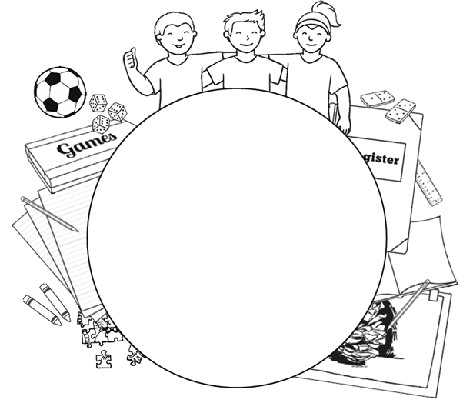
My Friends
I have lots of friends in school.
They are called ____________________________________________________________________________________________________________________________________

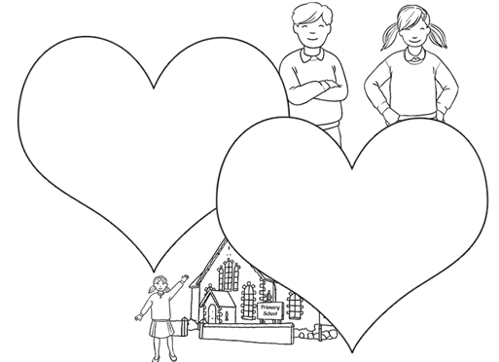
What I like About School

My favourite thing about school this year was __________
________________________________________________________________________________________
_________________________________________________________________________________________________________

Next Year!
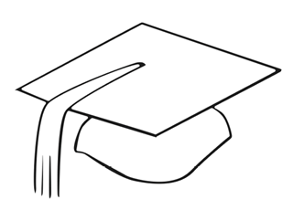

Next year I will be in _____________________
I am looking forward to ____________________
___________________________________
My teachers next year are called
______________________________________________________________________

School Holidays

In the summer, I am looking forward to ___________
__________________________________________________________________________________________________________________________________________________________________________________________________________________
