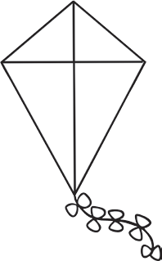
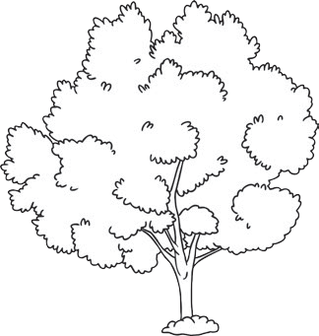
Read and Colour
Read the sentence in each box and colour the picture to match the sentence.

1.  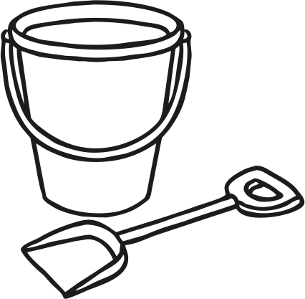  The bucket is red. The spade is yellow. | 2.    The sun is yellow. | 3.  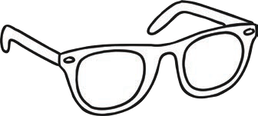  The sunglasses are pink.
4.  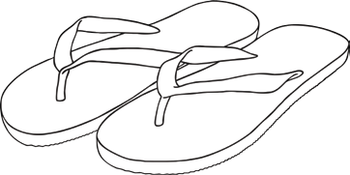  The flip-flops are green and orange. | 5.  The kite is green. | 6.  The tree is green and brown.
7.  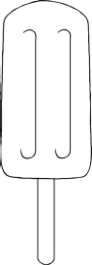  The lolly is red. | 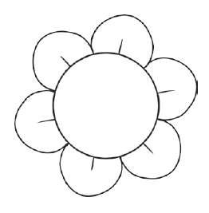  8.  The flower is pink. | 9.  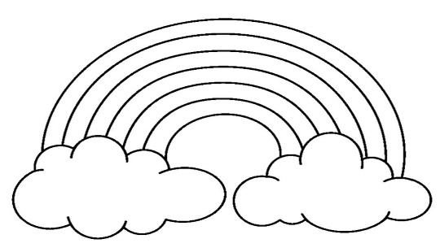  The rainbow is red, orange, yellow, green, blue and purple.

