End of Year Booklet
This is me in Class ___
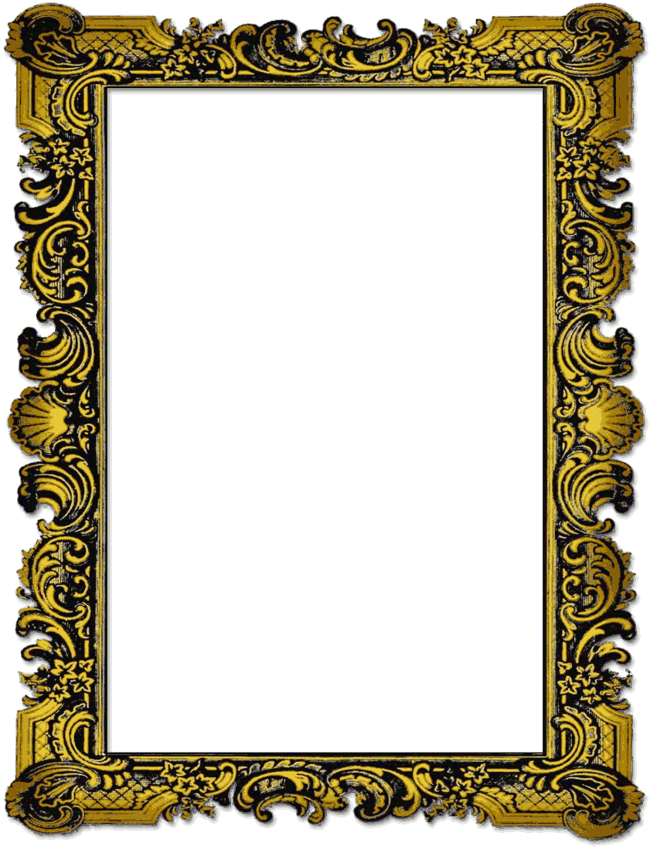

My School
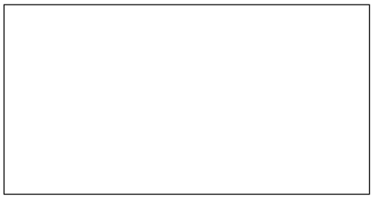

My school is called ________________________
___________________________________
It is a school for _________________________
It is in _______________________________
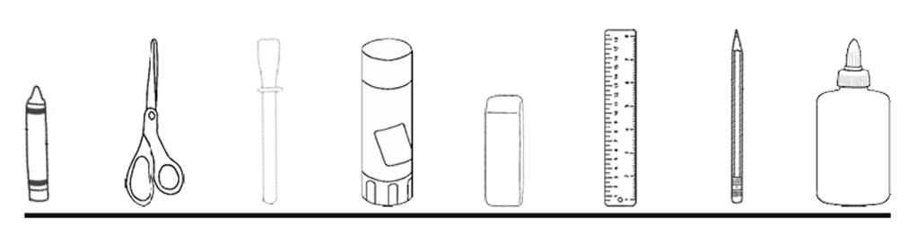
The head teacher is called ___________________
My Teachers
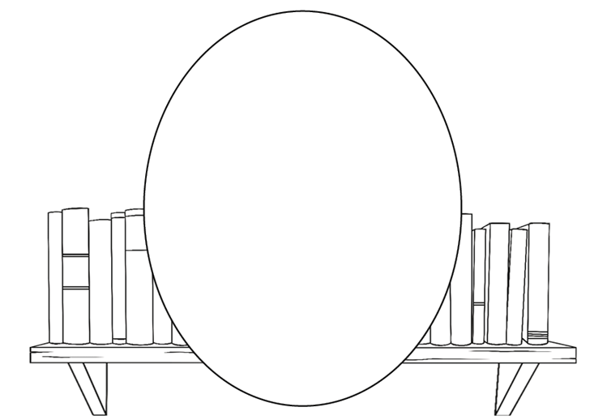

My teachers are called ___________________ and ___________________________________
I like my teachers because ___________________
_________________________________________________________________________________________________________
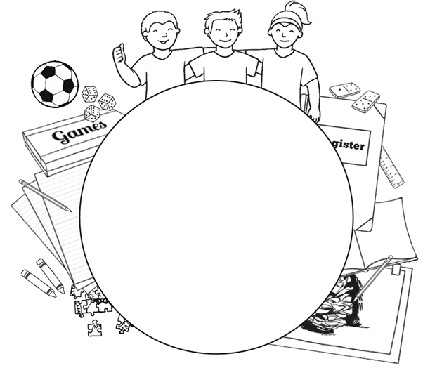
My Friends
I have lots of friends in school.
We like to ____________________________________
____________________________________________________________________________________________________________________________________

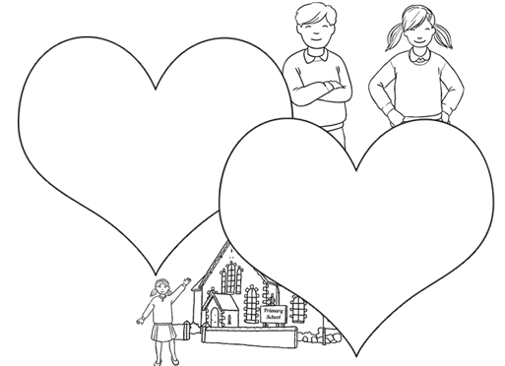
What I like About School

My favourite thing about school this year was __________
________________________________________________________________________________________
I liked how we always ______________________
_________________________________________________________________________________________________________

Next Year!
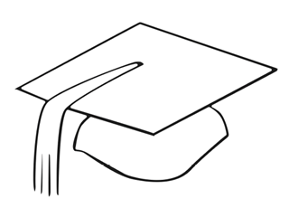

Next year I will be in _____________________
I am looking forward to ____________________
___________________________________
My teacher(s) next year is/are called ___________
___________________________________
Next year will be different because _________________
________________________________________________________________________________________

School Holidays

In the summer, I am looking forward to ___________
__________________________________________________________________________________________________________________________________________________________________________________________________________________
