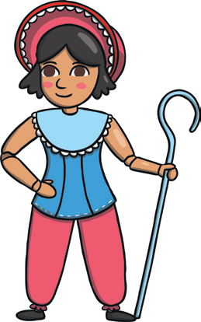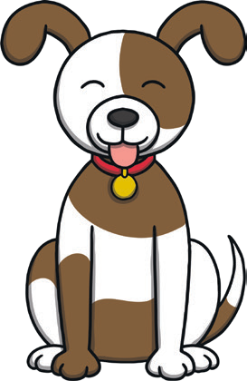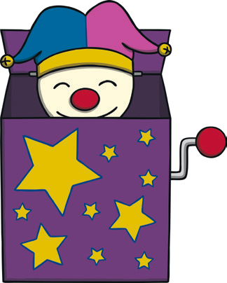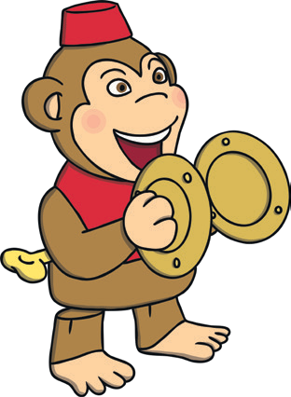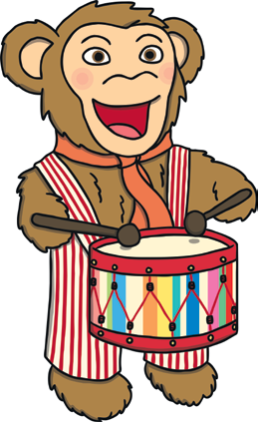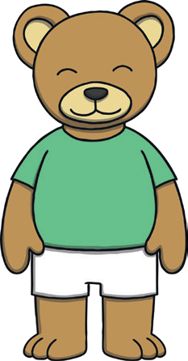
Halving Toys
- Count the toys. How many are there?
- Can you take half for yourself?
- Can you give your partner half of the toys?
- How many do you both have?
twinkl.com
Maths Mastery Home Learning Challenge
Adult Guidance
What Are We Learning?
We are learning to find half of a group of objects.

How to Set up the Challenge
- Place an even number of small toys between you and your child.
- The number of objects can be changed each time, but there must always be an even number.
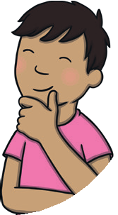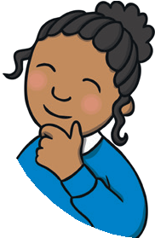

How to Get Your Child Thinking
- What does half mean?
- Are you sure you have half?
- How can you check?
- What do you notice about both halves?


visit twinkl.com

