
THANKS FOR NOT PRINTING THIS PAGE!

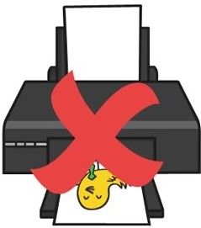
Simply print from page 2 in your printing options, to avoid wasted paper and ink.

To find out more visit www.twinkl.eo.uk/eco
"""

Thanks for downloading and welcome to the twinkl family!
If you love our resources, you'll love premium!

- Save valuable time- we know how precious time can be, so we've spent thousands of hours creating lovely resources, leaving you to focus on what's most important.

- All the tools and materials you will need to create an amazing learning environment for your little stars.!

- The largest collection of premium resources on the web at less than lp per resource!

- Find out more about Twinkl premium at www.twinkl.co.uk/premium

How to change the print size of this resource
- In your PDF reader, click the 'File' menu

- Select 'Print'

- Click the box next to 'Print Scaling' and select 'Multiple Pages Per Sheet'

- You will now have various options, which will enable you to print several pages on just one sheet of paper.
A brief word about copyright... twtnkl
By downloading this resource, you agree to the following:

Scan OR Code




You may use this resource for personal and/or classroom use only. We're more than happy for you to keep your own backup copy though.

In order to support us, we ask that you always acknowledge www.twinkl.co.uk as the source of the resource. If you love these resources, why not let others know about Twinkl?

You must not reproduce or share this resource with others in any form. They are more than welcome to download the resource directly from us.


You must not host or in any other way share our resources directly with others, without our prior written permission.

We also ask that this product is not used for commercial purposes and also that you do not alter the digital versions of our products in any way.

We hope you erjoy the resource and we1l see you very soon! x
www.twinkl.co.uk © twinkf ltd

Date Name
Matching shadows with pictures
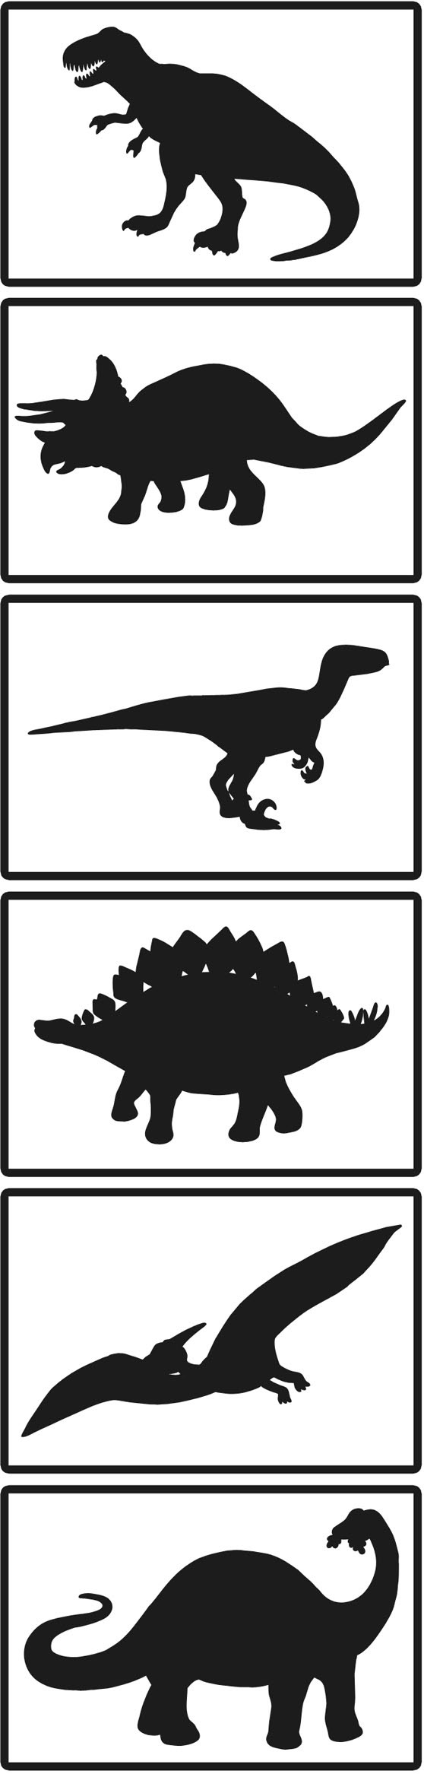
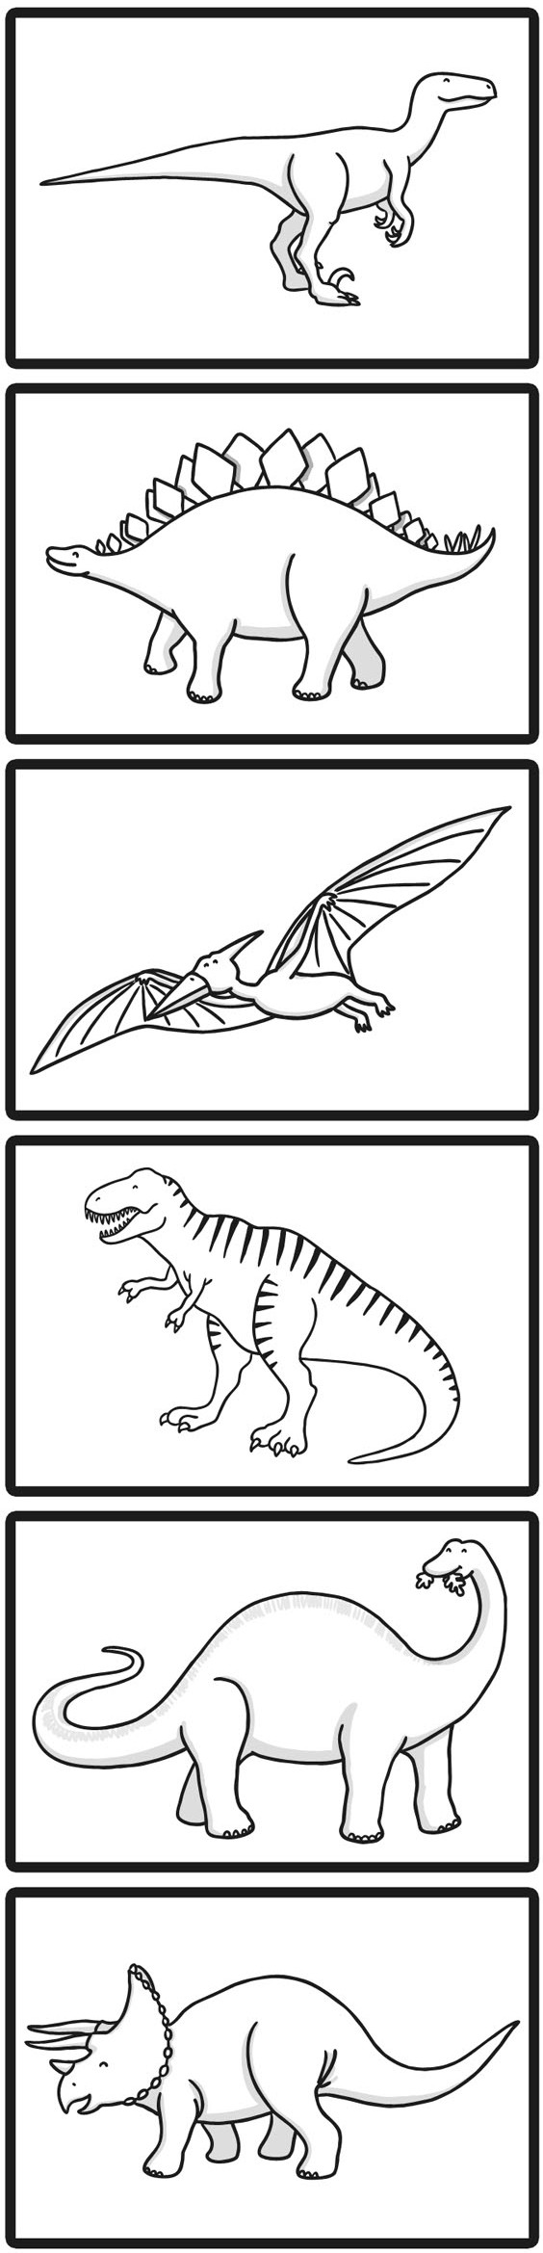
Draw lines to match. th.e sh.adows with. th.e correct picture on th.e righ.t.
www.twinkL.co.uk Copyright© Twinkl Ltd

