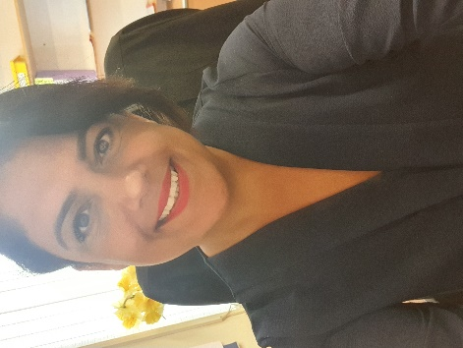
A letter from Mrs Goulthorpe

Dear Year 2 children
Many of you don’t know me. My name is Mrs Goulthorpe and when Mrs Elliot left I became the new head teacher here at Enderby Road Infants.
I am writing to you all because many of you have had to miss school because of the Covid virus and your parents and carers have had to keep you at home as part of keeping everyone safe.
We know that as Year 2 children things will be very different when you start your new school in September. You will be Year 3 children and there will be new teachers and maybe new friends to get to know. BUT…lots of things won’t change.
At Enderby Road Infants the grown-ups are always thinking about you every single day. They laugh at the funny things you have done and wonder if you are still getting better at your handwriting and what you are reading now. I love hearing about you all and even though I haven’t met most of you, I feel like I know a lot about you. We do hope you are safe and happy and having lots of fun with your families.
Your teachers are still planning learning activities for you to do so don’t forget to look on the website for this. There is also a letter sent to you every week by your class teacher. You can find this in the homework section. We are in the middle of planning an exciting event for you to attend before the summer holidays. We will let you and your parents know about this very soon!
I know you don’t know me as the new head teacher but I want to tell you some important things,
- The staff here love you, even though they haven’t seen you for a while.
- Don’t be frightened. You maybe worried about things. Tell someone you trust about your worry and let them look after it for you.
- The children who are back at school are not more special than you. You are all special.
- We are working with your new Junior schools to make sure they have everything ready for you for when you start. I know your new teachers are very excited about meeting you.
- There are some good things happening. There is less air travel and as a result the environment is getting a bit of a rest and who knows maybe we can work out new and better ways of doing things in the future, because we have to. People are talking to each other and offering to help each other more. That is a very good thing. Make sure you do that too!
- Even though you will be missing school, you can still learn and try your best at everything you do.

You are a very special bunch of people!

I know we will be saying goodbye to you soon but please keep singing, playing, making, drawing, writing, problem solving and learning about our amazing world. We are having an adventure and like all real adventures, we have to be brave!

