Using Question Marks
Can you fill in the missing question word from the word bank? Add the correct punctuation to the end of each question sentence.
______________ are you having for tea
Can
How
What
______________ are you
Is
When
Why
______________ you help me
______________ is coming to the party
Could
What
Who
______________ day is it today
Do
Would
______________ you pass me a pencil please
______________ you like peas
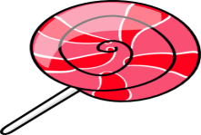
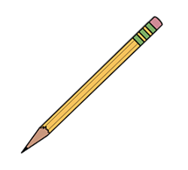
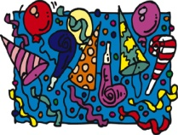

______________ it cold outside
______________ you like a sweet

