Enderby Road Infant School- School Uniform
Our official school uniform supplier is:
Shah’s School Wear
109 – 111 West Street
Scunthorpe
North Lincolnshire
DN15 6EQ
Telephone: 01724 844934

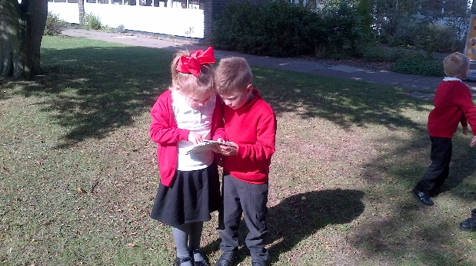

Our uniform consists of:
- Red sweatshirt / cardigan (with or without school logo)
- White or red polo shirt OR white shirt / blouse
- Plain black or grey trousers, skirt, pinafore, or tailored shorts
- Girls can wear a red and white summer gingham dress
- Plain black school shoes
All uniform with embroidered logo can be purchased directly from Shah’s clothing store in Scunthorpe or via their website using the link below:
www.shahsuniform.co.uk
P.E. Kit
- Black / Red shorts
- White t-shirt/polo shirt (with or without logo)
- Plimsolls/trainers
- Items to be placed in a drawstring bag

All items must be labelled clearly with your child’s name.
No jewellery (except stud earrings) must be worn
Stud earrings must be taken out on P.E. days (or provide plasters to cover them up)
Please find below a pricelist for all Official School Uniform.
If you have any problems please contact the school office on 01724 861571

