A school can decide how to use the funding and our efforts at ERIS are focused on supporting the individual learning of targeted pupils. At ERIS we all offer various services and enrichment, all of which have been agreed by our school governors. We must publish details on how our schools spend the pupil premium funding and the effect this has had on the progress and attainment of the pupils who attract the funding. These reports can be found on our school website.

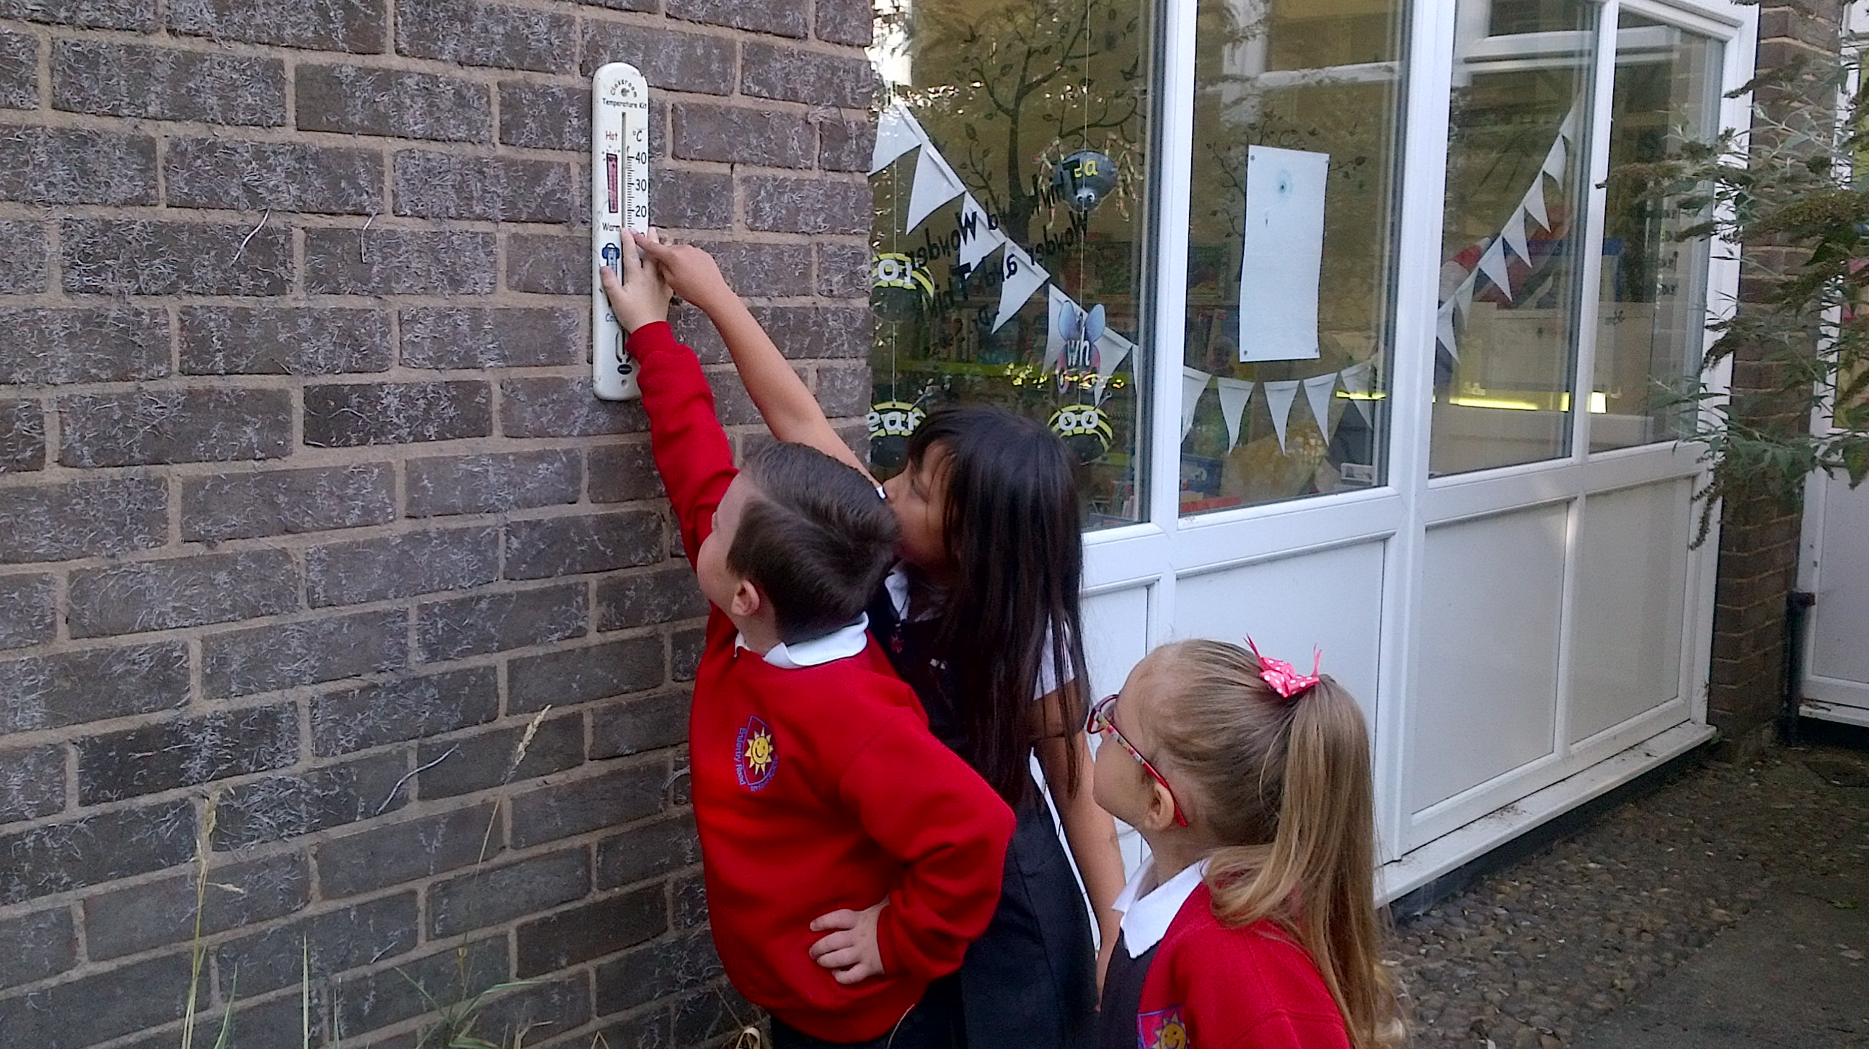

Find out more about our Pupil premium strategy on

https://enderbyroadinfantandnursery.co.uk


At our school we aim for all children to be successful and make exceptional individual progress. We endeavour to ensure all children have a ‘love for learning’ and enjoy all aspects of school life. On a weekly basis we want all children have the opportunity to ‘narrow the gap’, targeting precision teaching for every child
Our curriculum includes opportunities for children to learn through first hand-experiences. We will subsidise our curriculum visits outside of school and aim to further enhance our existing topic-based approach to suit the needs and interests of our children. We will also offer the support of a Pastoral Team who will support families with attendance, welfare issues, parent skills and engagement and also offer guidance to parents on behaviour.

.

We think there may be many families who could be eligible but have not applied for a range of reasons. The Pupil Premium money could make a big difference to your child’s future; more support with key skills, clubs, mentoring, specialist training for staff, better resources, social and emotional support.
At ERIS, we are committed to ensuring that all our children make the best possible progress. Our key priorities are high expectations and good quality teaching and learning for all pupils.
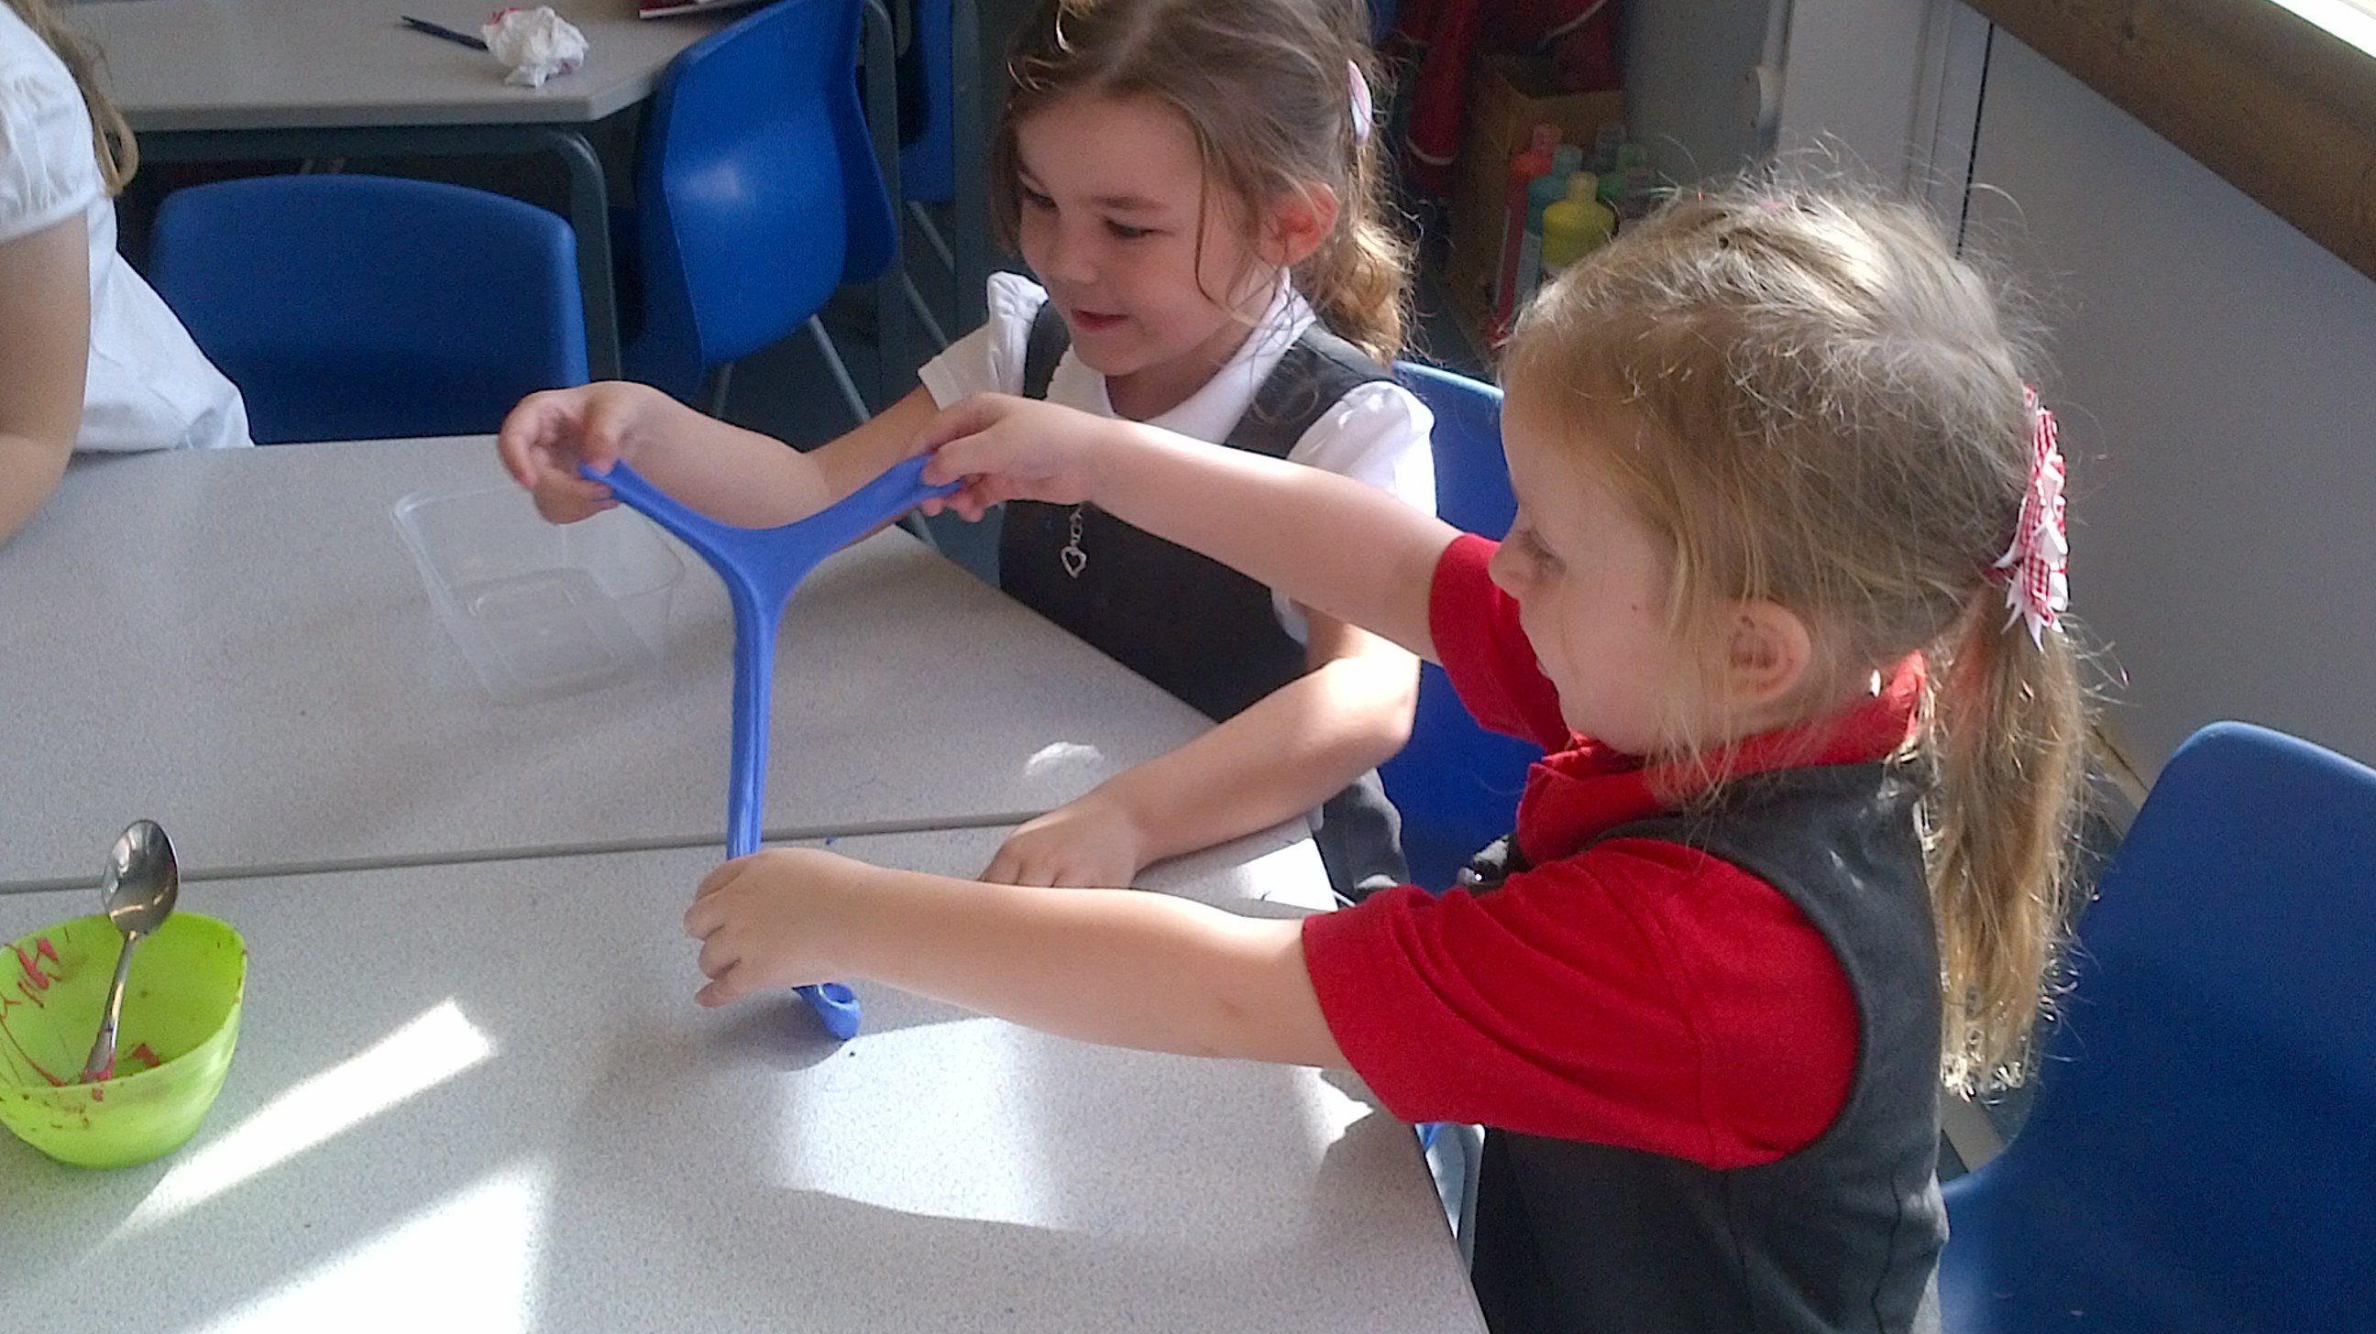

Our priorities are focused on narrowing the attainment gap for those pupils not on track to meet age related expectations at the end of the academic year in English (Reading and Writing) and Mathematics and closing the gap for all Pupil Premium children. We will use a range of strategies to raise engagement and attainment and also a focus on providing Well-being support and nurture for vulnerable children and their families.



