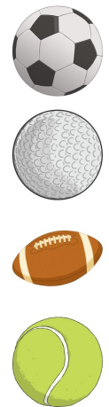
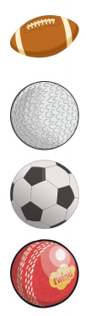
Which is the Bounciest Ball?
I am using the following balls:
(Draw and label the balls you will use)
Before you start: Prediction:
I think the___________________________
will be the bounciest.

Result: Which ball was the bounciest?
The ________________________________
was the bounciest.

