Class 3 Home learning (Y1)
Summer term week 3: 15.6.20

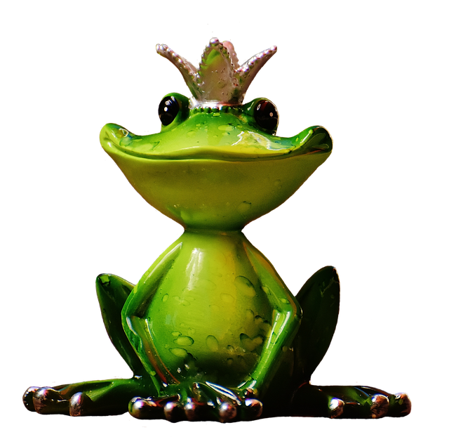
LITERACY: The Frog Prince

Monday: The Frog Prince story
Please watch the cartoon version of the Frog Prince story with your child:
https://www.youtube.com/watch?v=4RBqu4B2-po

Then ask the following questions:
Who is the first character in the story? (The Princess)
What did she lose in the pond? (A golden ball)
How did she feel when she lost her ball and how do you know? (She was sad and started to cry)
What did the frog want in return for getting the ball? (To eat from her golden plate and sleep on her bed)
What did the King tell the princess to do? (Let the frog come in because a promise must be kept)
Was the princess happy to share her food and have the frog sleep on her pillow? (No)
What did the frog turn into? (a handsome Prince)
Who had changed the Prince into a frog? (a wicked fairy)
Then discuss what is your child’s favourite part of the story and why.

Tuesday: Character descriptions
Please click on the link below to watch another version of the Frog Prince story:
https://www.twinkl.co.uk/resource/t-t-5343-the-frog-prince-story-powerpoint
Please remember if you enter www.twinkl.co.uk/offer, you can then enter your details on the right hand side and use the code CVDTWINKLHELPS. This then allows you FREE access.
Then discuss the two main characters- the frog and the Princess.
Ask your child to draw a careful picture of each and then write adjectives (describing words) around the picture.

Wednesday: Own version
Use the sequencing cards on the following link to help your child rewrite the story of the Frog Prince.
They don’t need to copy the original, they should write it in their own words. They will have today and tomorrow to do this so no need to rush.
Please remind your child about capital letters, finger spaces and full stops.

https://www.twinkl.co.uk/resource/t-t-4070-the-frog-prince-story-sequenging-4-per-a4

There is a word mat on Twinkl to help too:
https://www.twinkl.co.uk/resource/t-t-4075-the-frog-prince-word-mat

Thursday: Own Version
Finish writing the Frog Prince story started yesterday.

Friday: Creative links
Please choose from the egg carton frog:
https://www.dltk-kids.com/animals/mfrog-egg.htm

or a paper plate frog:
https://www.dltk-kids.com/animals/mpfrog.html

Y1 PHONICS: Phase 4
This week in school, we would have continued our phonics learning in Phase 4.
Phase 4 Tricky words for reading are: said, so, have, like, some, come, were, there, little, one, do, when, out, what.
Phase 4 Tricky words for spelling are: he, she, we, me, be, was, you, they, all, are, my, her.

This week we will continue to use the espresso website.
Please click on the link: https://online.espresso.co.uk/espresso/login/Authn/UserPassword
Username: student27049
Password: sunshine
On the My services page, click on the box marked ‘Discovery Education:espresso’.
Then in the search box at the top, type ‘Kims phonics’. You then need to click on the first page that comes up.
You should arrive at a picture of a boy on a boat sailing around lily pads with writing on.

Monday: Click on the lily pad marked- ‘Words ending cc(1)’
Please watch the video with your child to encourage them to join in.
Then click on the suggested activities in the box on the right hand side of the screen- blending, reading and spelling.

Tuesday: Click on the lily pad marked ‘Words ending cc (2)’
Again, please watch the video and complete the activities.

Wednesday:
Ask your child to write down some of the tricky spelling words: he, she, we, me, be, was.
They could write them in brightly coloured pens or as big as they can!
Then go back to the espresso website as yesterday:
Click on the lily pad marked ‘Tricky words’
Click on the activities- ‘Read the sentence’ and ‘alien words’.

Thursday: Go on the Phonics play site https://new.phonicsplay.co.uk/
and play Buried Treasure game
Phase 4- CCV and CCVC words Set 1-7 Plus digraphs

Friday: Go on the Phonics play site again
This time, play Rocket Rescue Phase 4

