Class 3 Home learning (Y1)
Summer term week 2: 8.6.20
LITERACY: Frogs
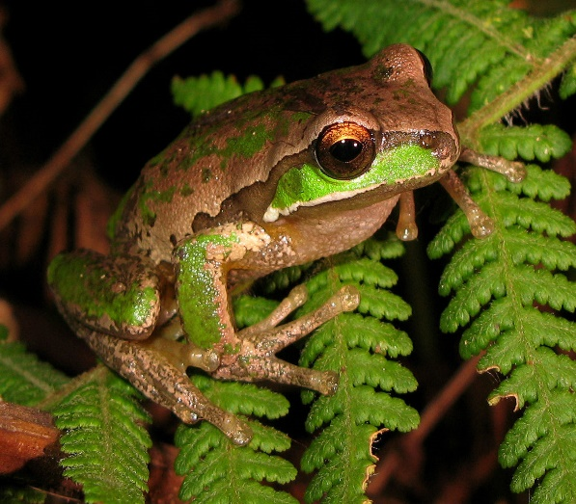
Unknown Author is licensed under CC BY-SA
Monday: Introduction to frogs
Please watch this short clip showing lots of different frogs:
https://www.bbc.co.uk/teach/class-clips-video/science-ks1-ks2-wonders-of-nature-frogs-in-their-habitat/z63ygwx
Then with your adult, watch this clip from San Diego Zoo:
https://www.youtube.com/watch?v=oMFxQsaT274

and answer the following questions:

Q1. What are amphibians? (It means ‘double life’ and shows that the frog can live in water and on land)
Q2. How many types of frog are there? (4000)
Q3. Which parts of the world are they found in? (All over the world but mostly they are found in tropical rainforests)
Q4. Why are some frogs brightly coloured? (To warn other animals, don’t eat me I’m poisonous)
Q5. What does ‘Camouflage’ mean? (It means to be coloured to blend on or hide in the environment. This makes it difficult to spot them.)
Q6. How long is the smallest frog at the zoo? (Half an inch long)
Q7. Why do frogs have long legs? (For climbing and jumping)
Q8. What is one thing that all frogs have in common? (They love to eat!)

You could also talk to your adult about your favourite frog in the video and why you like it so much.
Tuesday: The Frog Life cycle.

Please click on the link below:
https://www.youtube.com/watch?v=GgCL3JenMCs

Then look at this life cycle powerpoint:
https://www.twinkl.co.uk/resource/t-t-5230-frog-life-cycle-powerpoint

Please remember if you enter www.twinkl.co.uk/offer, you can then enter your details on the right hand side and use the code CVDTWINKLHELPS. This then allows you FREE access.
Now divide an A4 piece of paper into four parts and label them like below:
Frog spawn | Tadpole | Froglet | Frog

Please draw a picture of each stage in the frog life cycle in the correct box.

Wednesday: Labelled drawing of parts of a frog
Draw and label the parts of a frog using the link below as a guide.
https://www.twinkl.co.uk/resource/t-sc-261-parts-of-a-frog-differentiated-activity-sheet
Please include: eyes, throat, back, forelegs and hind legs.

Thursday: Reading Game
Logon to Classroom Secrets Kids. https://kids.classroomsecrets.co.uk/
Click on the Year 1 tab and then on reading.
Play the ‘Y1 Animals Reading Comprehension Missing Pet’ game (it’s about a missing frog!)

Friday: Creative links
Please choose one from below:
Have a go at drawing a cartoon frog using the link below.
(The children have used these videos before to draw other things so are used to this format!)
https://www.youtube.com/watch?v=n_kovglf_eM
Make your own ‘bouncing frog’ using this link: https://www.twinkl.co.uk/resource/t-t-20770-origami-frog-hoppers-activity-instructions
Y1 PHONICS: Introduction to Phase 4
This week in school, we would have started Phase 4.
In Phase 4 children are not taught any new phonemes or graphemes. Instead, they are taught to further manipulate the phonemes and graphemes they have already learnt. Many of the words children explored in Phase 2 and 3 were monosyllabic (words of one syllable). In Phase 4 children explore more polysyllabic words (words containing more than one syllable).
Many of the words in Phase 2 and 3 required children to blend approximately three sounds together in order to read them. Phase 4 requires children to blend an increasing number of sounds together in order to read.
Phase 4 Tricky words for reading are: said, so, have, like, some, come, were, there, little, one, do, when, out, what.
Phase 4 Tricky words for spelling are: he, she, we, me, be, was, you, they, all, are, my, her.
This week we will be starting to use the espresso website. This is another website we use in school.
Please click on the link: https://online.espresso.co.uk/espresso/login/Authn/UserPassword
Username: student27049
Password: sunshine
On the My services page, click on the box marked ‘Discovery Education:espresso’.
Then in the search box at the top, type ‘Kims phonics’. You then need to click on the first page that comes up.
Hope this all makes sense! You should arrive at a picture of a boy on a boat sailing around lily pads with writing on.

Monday: Click on the lily pad marked- ‘Words beginning cc(1)’
Please watch the video with your child to encourage them to join in.
Then click on the suggested activities in the box on the right hand side of the screen- blending, reading and spelling.

Tuesday: Click on the lily pad marked ‘Words beginning cc (2)’
Again, please watch the video and complete the activities.

Wednesday: Click on the lily pad marked ‘Tricky words’
Watch the video and then click on the activities- reading and spelling high frequency words.

Thursday: Go on the Phonics play site https://new.phonicsplay.co.uk/
and play Buried Treasure Phase 4-CVCC words Set1-7 (for practising blending)

Friday: Go on the Phonics play site again
This time, play Space Race- Phase 4 (for practising segmenting)

