Class 5 Daily Activities-Bees
Week 4
Day 5 Friday 15th May 2020
Literacy/Topic
Draw or paint a picture of a bee. You may want to draw your bee in a garden with lots of beautiful flowers! Or next to/inside its bee hive.

You might also like to get your crafting things out and have a go at making this bee.
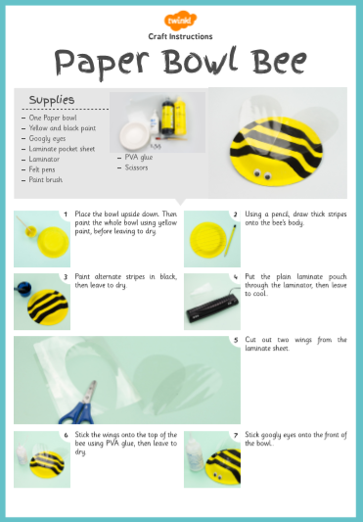
Maths
https://whiterosemaths.com/homelearning/year-2

Week 2-Lesson 5 ‘Equivalence of a half and 2 quarters’

