Class 3 Home learning Summer term week 4: 11.5.20
LITERACY: Ladybirds
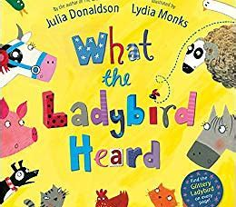
‘What the ladybird heard’ by Julia Donaldson and Lydia Monks
If you have a copy of this book, please share it with your child.
If not, this is the link to a reading on Youtube:
https://www.youtube.com/watch?v=bzNIERZUyEM
Monday: Read and respond to the story.
Please ask your child the following questions:
‘What’ Questions
1. What animal lived in the pond? (a duck)
2. What sounds did the cats make? (miaow and purr)
3. What colour was the van? (black)
4. What did the men want to steal? (the fine prize cow)
5. What were the men called? (Hefty Hugh and Lanky Len)
‘Who’ Questions
1. Who took the bad men away? (the police in their car)
2. Who called the police? (the farmer)
‘How’ Questions
1. How did the animals trick the two bad men? (the animals said the wrong sounds so the men were confused and fell in the pond)
2. How do you know the farmer was happy at the end of the story? (he cheered)
‘Why’ Question
1. Why did the farmer wake up? (the noise from the bad men falling in the duck pond)
You could also discuss what was their favourite part of the story and why.

Tuesday: Farmyard animals
Please share the book again with your child.
R: Ask them to choose three of their favourite animals from the story. Draw a careful picture of each and label it using your phonics to help you.
Extension: Write a super sentence for each for example The sheep is grey and woolly.
Y1: Ask them to choose 5 of their favourite animals from the story. Please remind them about starting with a capital letter, remembering finger spaces and ending with a full stop.

Wednesday: Introduction to ladybirds
Please click on the link below:
https://www.youtube.com/watch?v=nl7KqpqoN9o
Then on your daily walk or in your garden, see if you can spot a ladybird! What colour is it? How many spots does it have?
R- Draw a picture of a ladybird.
Y1- Draw a large picture of a ladybird and then label it. You need to include head, wings, legs and antenna.

Thursday: Looking at the life cycle of a ladybird (Your child may be surprised at what a young ladybird looks like!)
For this task, you will need to access Twinkl and use the FREE offer.
If you enter www.twinkl.co.uk/offer, you can then enter your details on the right hand side and use the code CVDTWINKLHELPS. This will then allow you access to the following links!
Please use this link to access a Twinkl Power point about the ladybird life cycle:
https://www.twinkl.co.uk/resource/t-t-5222-ladybird-life-cycle-powerpoint

Please talk to your child about what they have seen and then help them to divide a piece of paper into four parts and label them as below:
egg | Larvae | pupa | Adult ladybird

R: Ask them to draw a relevant picture in each box.
Y1: As above and then write a descriptive sentence about each stage.

Friday: Making a ladybird
Have a go at making your own ladybird! Please encourage your child to make them symmetrical (the same number of spots on each wing) and use whatever you can spare at home. Here are a few ideas:

You could use a paper plate: 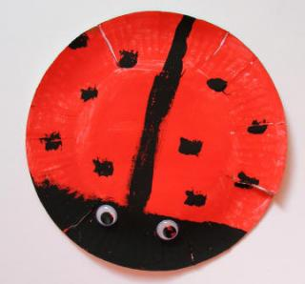
Or paint a pebble: 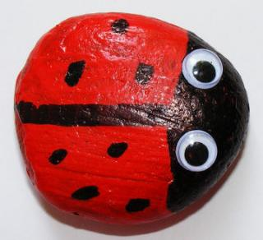

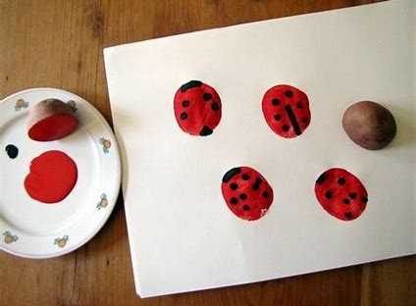 Or do some potato printing with red and black paint!
Hope you have fun!

PHONICS: Revision of Phase 3
This week in school, we would have begun our revision of all the Phase 3 sounds and tricky words.
Week 4: The focus is on ee, igh, oa and oo I recommend covering one sound a day for 4 days.
1. For the alphabet song (which we sing at the start of most sessions) please click on this link: https://www.youtube.com/watch?v=zM8reWWru1U
This is the closest I could find to the one we use in school!

2. Main revision of sound:
BBC Bitesize has a great section on Phase 3 Phonics.
Please find link here: https://www.bbc.co.uk/bitesize/topics/zvq9bdm
For each sound, there is a mini animation featuring two wizards and also an interactive game which you can access by clicking on the white arrow on the orange background (this is on the right hand side under the animation screen)
Please watch the bbc animation with your child and encourage them to join in.

3. There is a range of games on Phonics Play for applying the sounds. These are currently free to use:
Username:march20
Password: home
In class we normally use ‘buried treasure’ and ‘Picnic on Pluto’ the most. These are games that look at real and nonsense (alien) words using the daily focus sound.
We have also used the ‘tricky word trucks’ and ‘Rocket rescue’ so please feel free to use the other games that your child enjoys.

