Class 3 Home learning (Reception) Summer term week 3: 4.5.20
LITERACY: ‘A Place called Home’ by Addy Farmer and Louise Gardner 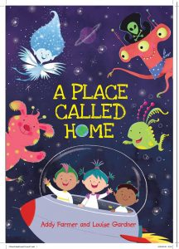
This week, we are doing more activities related to the book.
Monday: Recap and discussion
Read the story again with your child, encouraging them to join in with the parts they remember!
Then talk about
the setting of the story (space)
the characters (Eddy, Freddy, Blip, Pirates from Mars, bobble fish, frost fairies, Woollywoos)
the main events (what happens at the beginning, in the middle and at the end)
Which character would they like to be and why?

Tuesday: Bobble Fish
Look at the illustrations of the bobble fish in the story. Talk about the colours and parts of the fish (fins, tail)
You could use old CD’s or balloons to make your own bobble fish. If you don’t have those at home, your child could paint or draw a picture of a brightly coloured bobble fish.

Wednesday: Bobble Fish
You could have fun blowing and popping bubbles like a bobble fish! If you don’t have any bubble mixture at home, you could make some. The following ‘recipe’ is from the BBC Good food website:

Bubble mixture
Makes 350ml
Prep 5 minutes
- 50ml washing-up liquid (one part)
- 300ml water (six parts)

1. Measure the washing-up liquid into a container.
2. Slowly add in the water, being careful not to create too many bubbles at this stage. Gently stir the mixture together to combine – a chopstick is perfect for this.
3. If you can, let the bubble mixture rest before using it, as it will make your bubbles even better.
4. When you’re ready, dip your bubble wand into the mixture and start blowing bubbles!

Homemade bubble wands
If you don’t have a wand from a store-bought pot of bubbles, don’t despair! You can have fun by looking for different items around the house that can be used to make bubbles. Here are some ideas to get you started:
- Paperclips – bend them into wands or use as they are
- Straws
- Biscuit cutters

Thursday: Pirates from Mars
Make a pirate hat!
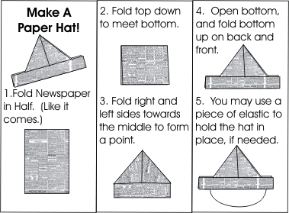
You could talk to your child about what language a pirate would use (yarr, arr, shiver me timbers etc)
Ask your child to pretend to be a pirate and rescue your family from the terrifying black hole in space! Do you have any other pirate stories that you could share with your child?

Friday: Pirates from Mars
Look at the illustrations of the pirates from Mars- what colour are they? How many eyes? How do you know they are pirates?
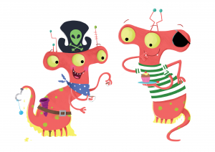
Ask your child to draw a picture of one of the pirates. They could copy an illustration or create their own. They then need to colour it in and write some sentences about it. Encourage them to use their sounds to help with their writing. They also need to start each sentence with a capital letter, remember finger spaces and finish with a full stop.

Please take a photo of their learning and upload it to their Tapestry account! I love to see their creations! Thank you!

PHONICS: Revision of Phase 3
This week in school, we would have begun our revision of all the Phase 3 sounds and tricky words.
Week 2: The focus is sh,th,ng and ai. I recommend covering one sound a day for 4 days.
1. For the alphabet song (which we sing at the start of most sessions) please click on this link: https://www.youtube.com/watch?v=zM8reWWru1U
This is the closest I could find to the one we use in school!

2. Main revision of sound:
BBC Bitesize has a great section on Phase 3 Phonics.
Please find link here: https://www.bbc.co.uk/bitesize/topics/zvq9bdm
For each sound, there is a mini animation featuring two wizards and also an interactive game which you can access by clicking on the white arrow on the orange background (this is on the right hand side under the animation screen)
Please watch the bbc animation with your child and encourage them to join in.
This week, please also look again at the tricky words video with your child. It is right at the bottom of the list of sounds.

3. There is a range of games on Phonics Play for applying the sounds. These are currently free to use:
Username: march20
Password: home
In class we normally use ‘buried treasure’ and ‘Picnic on Pluto’ the most. These are games that look at real and nonsense (alien) words using the daily focus sound.
We have also used the ‘tricky word trucks’ and ‘Rocket rescue’ so please feel free to use the other games that your child enjoys.

