Class 3 Home learning (Y1) Summer term week 3: 4.5.20
LITERACY
This week, we will be learning about Spiders.
Monday: Introduction to spiders and reading comprehension
Please click on the link below:
https://www.youtube.com/watch?v=WUx2qqPUyOI

Then ask your child them to carefully read the information below:

There are lots of different kinds of spider.
They can be very big or very small.
They can be found in lots of different places- in a shed, a field or even in your bath!
Spiders have 8 legs and have a body that has one big part and one small part.
They have very good eyes and can see around them.
There are about 40 000 species of spider in the world. Even though most are small, lots of people are scared of them.
The largest spider in the world is the Goliath bird-eating spider. They live in hot countries, up in trees and are the same size as a man’s hand. They don’t like to eat birds. They mostly eat worms and toads.
The smallest spider in the world is tiny. You can’t see it by just looking. You would have to use a magnifying glass to make it big enough to see.

Most spiders like to eat flies and other insects. Most spiders make webs to catch them in.

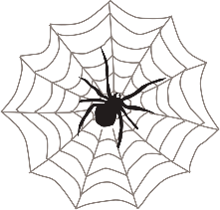

Then they need to answer these comprehension questions on a piece of paper.
1. Where in your house could you find a spider?
2. How many legs do spiders have?
3. How big is the world’s largest spider?
4. What does it like to eat?
5. What do most spiders like to eat?
6. How do spiders catch their food?

Tuesday: Spiders and label a spider
For this task, you will need to access Twinkl and use the FREE offer.
If you enter www.twinkl.co.uk/offer, you can then enter your details on the right hand side and use the code CVDTWINKLHELPS. This will then allow you access to the following links!
Please click on the link below:
https://www.twinkl.co.uk/resource/t-t-5105-spiders-facts-powerpoint
Then ask your child to do a careful drawing of a spider and label the parts:
Leg, claw, head, abdomen, eye, spinnerets.

Wednesday: Spider Lifecycle
Please click on the link below:
https://www.twinkl.co.uk/resource/t-t-5278-spider-life-cycle-powerpoint
Then ask your child to draw the spider life cycle. I would recommend folding an A4 piece of paper into four equal parts and then put a label at the top of each:

Female adult lays eggs | eggs | spiderlings | Adult spider

They can then add careful drawings to show each stage.

Thursday: How do spiders make webs?
Please click on the link below to watch a short video:
https://www.bbc.co.uk/bitesize/clips/zg7w2hv
Now create a spider fact file using all the information from this week.

Friday:
Completion of spider fact file
If you have time you could have a go at making your own spider web!
Here are some ideas:

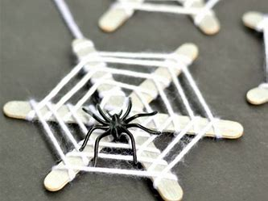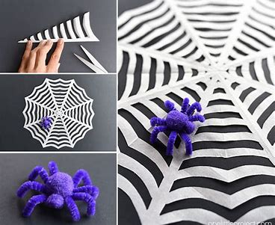

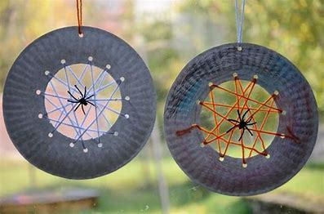

PHONICS: Revision of Phase 3
This week in school, we would have begun our revision of all the Phase 3 sounds and tricky words.
Week 3: The focus is sh, th, ng and ai. I recommend covering one sound a day for 4 days.
1. For the alphabet song (which we sing at the start of most sessions) please click on this link: https://www.youtube.com/watch?v=zM8reWWru1U
This is the closest I could find to the one we use in school!

2. Main revision of sound:
BBC Bitesize has a great section on Phase 3 Phonics.
Please find link here: https://www.bbc.co.uk/bitesize/topics/zvq9bdm
For each sound, there is a mini animation featuring two wizards and also an interactive game which you can access by clicking on the white arrow on the orange background (this is on the right hand side under the animation screen)
Please watch the bbc animation with your child and encourage them to join in.
This week, please also look at the tricky words video with your child. It is right at the bottom of the list of sounds.

3. There is a range of games on Phonics Play for applying the sounds. These are currently free to use:
Username: march20
Password: home
In class we normally use ‘buried treasure’ and ‘Picnic on Pluto’ the most. These are games that look at real and nonsense (alien) words using the daily focus sound.
We have also used the ‘tricky word trucks’ and ‘Rocket rescue’ so please feel free to use the other games that your child enjoys.

