Class 3 Home learning (Reception) Summer term week 2: 27.4.20
LITERACY
‘A Place called Home’ by Addy Farmer and Louise Gardner
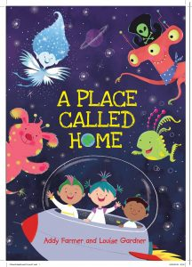

This is the lovely book that was posted through your door last week!
Monday: Read and respond to the story.
Please share the book with your child. Encourage them to join in with the repeated parts such as ‘Rockets ready, push the button, whee said Eddy etc and regularly pause and ask them what they think might happen next.
There are also lots of rhyming words in the story so see if your child notices them and discuss what a rhyming word is (it sounds the same at the end of the word)
After sharing the book, please ask your child the following questions:
1. What were the names of the children in the story? (Eddy, Freddy and Blip)
2. How did they get into space? (a rocket)
3. What planets did they go to? (a sea/water planet, an ice/frozen planet, Woolly Woos wood and earth)
4. Who saved them from the black hole? (the pirates with a net)
5. What happened at the end? (the pirate aliens came to earth and had cakes with them)
6. What was your favourite part of the story? Why?
The author has posted a video of herself reading the story with sound effects. Please find the link here:
https://www.youtube.com/watch?v=jZaQ8y5fIMI&list=UUAzyfMbSLExZDjIx4sJEZbw&index=2&t=0s
Tuesday and Wednesday: Blast off in your very own Rocket!

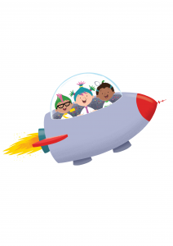
Tuesday: Use cushions, pillows, blankets and socks for the rocket, spoons and lids for the controls. Take your family and toys for a ride into outer space!!

Wednesday: Do a drawing, painting or make your own rocket by junk modelling (using old plastic pots, cardboard boxes etc)

Thursday and Friday: Design your own alien!
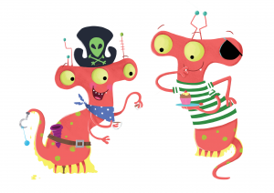
Thursday: Ask your child to use their imagination and create an extraordinary alien! How many heads will it have? How many eyes? Arms? Legs? What colour will it be?
Draw a careful picture of it and colour it in.

Friday: Ask your child to write sentences about their alien. Please encourage them to use their sounds to help with spelling. They should start each sentence with a capital letter, remember their finger spaces and finish with a full stop. They could use ‘and’ to make them super sentences! eg The alien is red and has three eyes.
Please take a photo of their learning and upload it to their Tapestry account! I love to see their creations! Thank you!
PHONICS: Revision of Phase 3
This week in school, we would have begun our revision of all the Phase 3 sounds and tricky words.
Week 2: The focus is y, z/zz, qu and ch. I recommend covering one sound a day for 4 days.
1. For the alphabet song (which we sing at the start of most sessions) please click on this link: https://www.youtube.com/watch?v=zM8reWWru1U
This is the closest I could find to the one we use in school!

2. Main revision of sound:
BBC Bitesize has a great section on Phase 3 Phonics.
Please find link here: https://www.bbc.co.uk/bitesize/topics/zvq9bdm
For each sound, there is a mini animation featuring two wizards and also an interactive game which you can access by clicking on the white arrow on the orange background (this is on the right hand side under the animation screen)
Please watch the bbc animation with your child and encourage them to join in.
This week, please also look at the tricky words video with your child. It is right at the bottom of the list of sounds.

3. There is a range of games on Phonics Play for applying the sounds. These are currently free to use:
Username: march20
Password: home
In class we normally use ‘buried treasure’ and ‘Picnic on Pluto’ the most. These are games that look at real and nonsense (alien) words using the daily focus sound.
We have also used the ‘tricky word trucks’ and ‘Rocket rescue’ so please feel free to use the other games that your child enjoys.

