Thursday 30th April
Task 1
You are almost ready to start your Space adventure but first you need to tell me where you are going. Can you draw or make a new planet. You might want to draw, paint or make a cut and stick picture of your planet. You can choose how you want to do this. I would also like you to tell me a little bit about it. Below is a sheet which might give you some ideas or you could copy the way that it is set out to help you present your own planet.
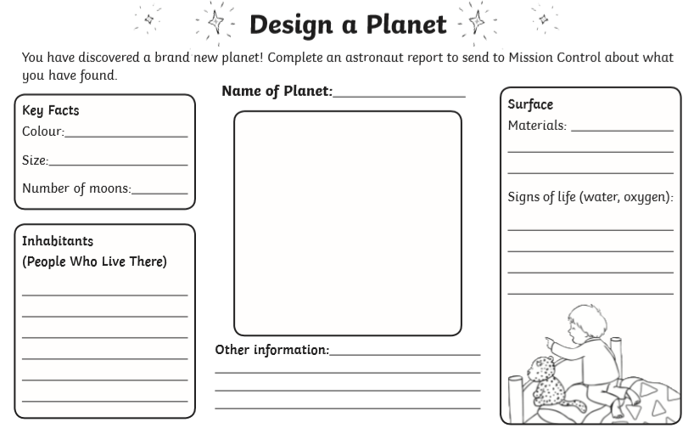
Task 2
Have a look outside your window tonight. What can you see?
Can you see the moon tonight and what shape is it?
How many stars can you see? Can you count them all?

