Wednesday | Read ‘The Cautious Caterpillar Butterfly Life Cycle Differentiated Guiding Reading’ and answer the questions.  https://www.twinkl.co.uk/resource/t-l-526335-the-cautious-caterpillar-butterfly-life-cycle-differentiated-reading-comprehension-activity | Summer Term Week 1 – Lesson 3  Video then ‘Make Equal Groups’
Thursday | Read ‘The Cautious Caterpillar – Lifecycle of a Butterfly’ powerpoint, then draw and label your own ‘Butterfly Lifecycle’.  https://www.twinkl.co.uk/resource/t-l-526348-the-cautious-caterpillar-life-cycle-of-a-butterfly-powerpoint | Summer Term Week 1 – Lesson 4  ‘Flashback’ then ‘Find a Half’
Friday | Draw and label a butterly using the picture and words found on page 3 of the link below.  https://www.twinkl.co.uk/resource/t-t-982-parts-of-the-insect-activity | Summer Term Week 1 – Lesson 5  Friday Challenge!
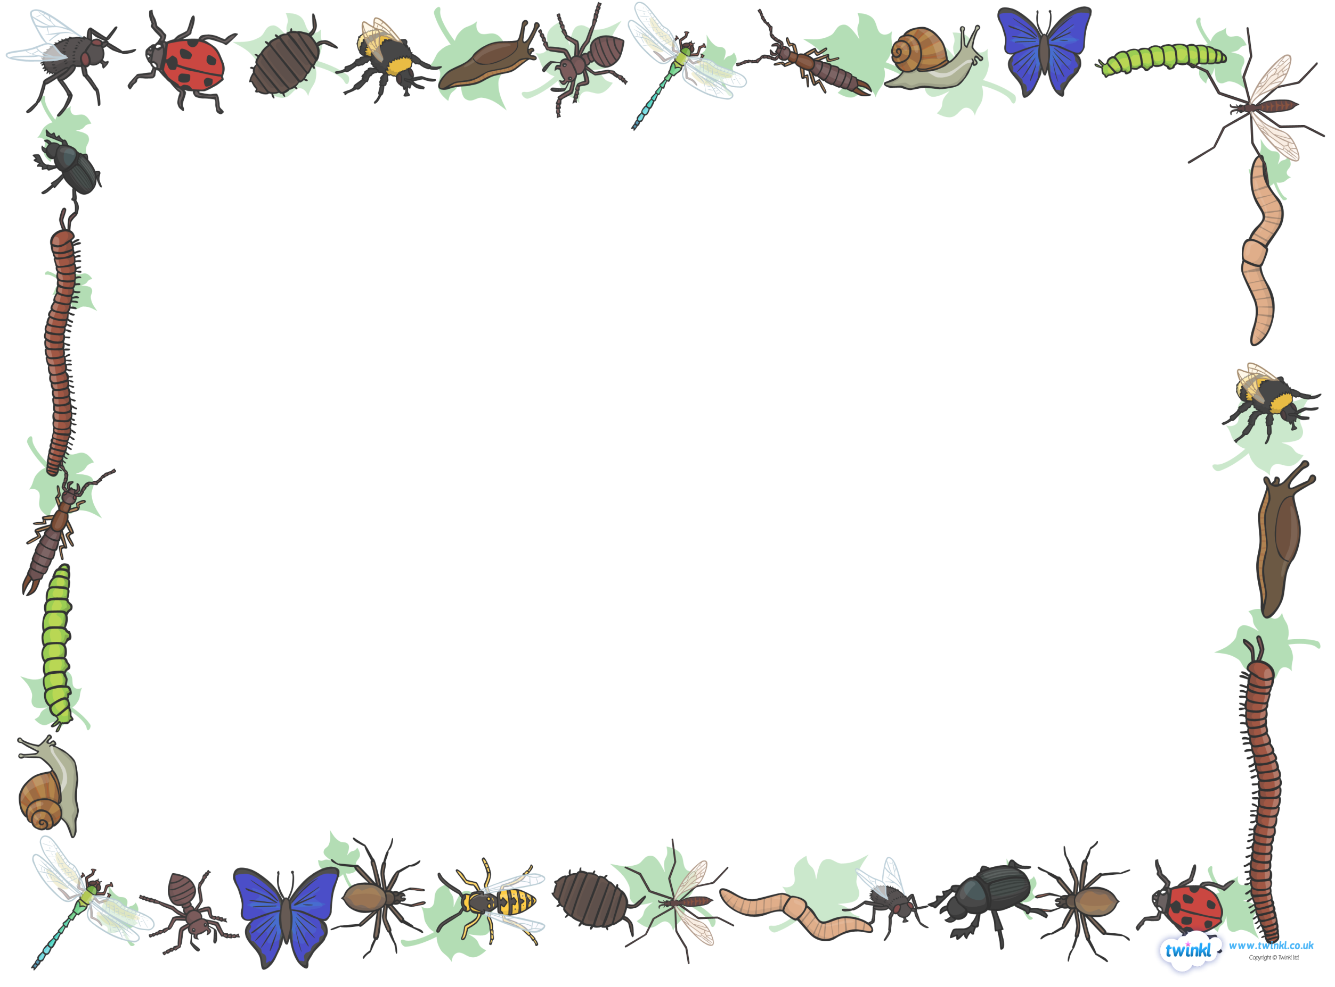
Class 4 Daily Activities
Wriggle and Crawl – Week 1

