Friday 24th April
Task 1
Can you write a few sentences about your ‘favourite things’? Remember to check your work carefully to make sure it has the correct punctuation (capital letters, full stops, finger spaces, exclamation marks and question marks). Can you include some interesting adjectives and conjunctions?

Task 2
Last term we did lots of work on money. Can you show me how many ways you can make these amounts?
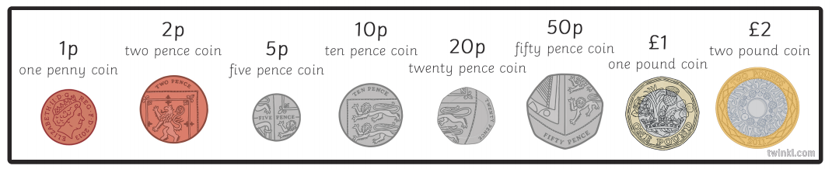
Example. I can make 15p
5p + 5p + 5p = 15p
10p + 5p = 15p
1p + 1p + 1p + 1p + 1p + 5p + 5p = 15p
- 10p g. 74p
- 25p h. £1
- 54p i. £1.55p
- 30p j. £3
- 63p k. £5
- 46p l. £10

