Wednesday 22nd April
Task 1
Writing sentences with a conjunction.
How many interesting sentences can you write using one of these conjunctions? (Remember: Capital letters and full stops)
because and but so then until while

I went to the park until it got too dark to play.
I want to go to the beach this afternoon but it has started to rain.

Challenge: can you think of a different conjunction that you could use in a sentence?

Task 2
How many ways can you show me these calculations?
Example. 5 x 3 = 15
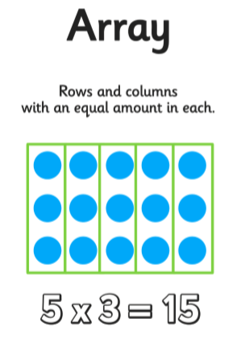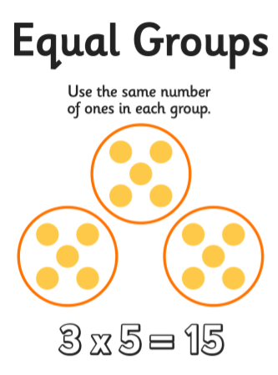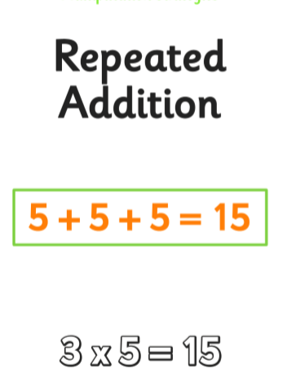
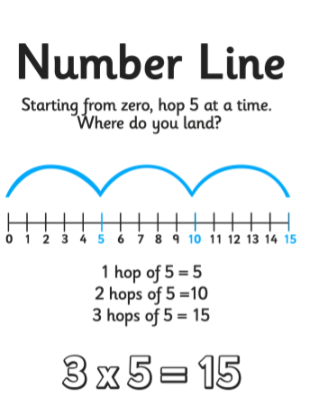
a. 2 x 4 = f. 6 x 5 =
b. 10 x 3 = g. 2 x 7 =
c. 3 x 3 = h. 3 x 10 =
d. 8 x 2 = i. 4 x 2 =
e. 4 x 3 = j. 5 x 4 =

