Tuesday 21st April
Task 1
Can you write a list of contractions? Here are a few to get you started. How many can you think of?
will not = won’t
do not = don’t
he will = he’ll
Task 2
Can you add these numbers using column addition (remember to add the ‘ones’ column first and then the ‘tens’ column).
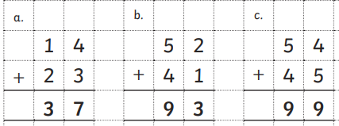
d. 32 + 32 j. 38 + 31
e. 10 + 44 k. 74 + 21
f. 54 + 32 l. 52 + 4
g. 74 + 21 m. 152 + 122
h. 63 + 24 n. 234 + 423
i. 21 + 37 o. 321 + 63

