 | Week 1  Healthy Eating Week/Father’s Day | Week 2 | Week 3 |  | Week 4 | Week 5
1 Point  (MUST complete) | Maths and English | Maths and English | Maths and English |  | Maths and English | Maths and English
Date Completed
Home Comments
2 Points  (OPTIONAL)  Can be completed in any order! | Activity 1    Design your own throne | Activity 2  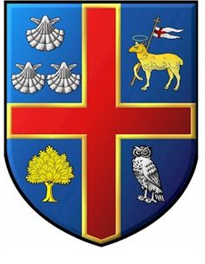  Make a shield and design your own coat of arms to decorate it. This could include: your favourite thing, your favourite place, your favourite animal etc. |  | Activity 3  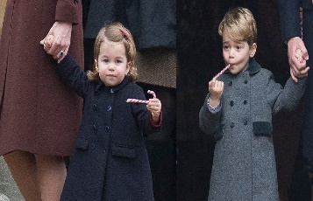  Imagine that you are nanny to Prince George and Princess Charlotte. Write a diary entry describing a day in the life of a Royal Nanny. | 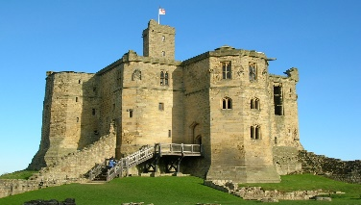  Activity 4  Safely use the internet to research castles. Write five fantastic facts about them. |   Activity 5  Think about Year 2. Write a letter to a Year 1 child to tell them all about what they will learn about and what you enjoyed in Year 2.
Date Completed
Home Comments
3 Points  (OPTIONAL)  Can be completed in any order! | Activity 1  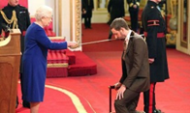  Design a medal for the Queen to award. | Activity 2    Make a 3D model of a castle or a palace that a king or queen could live in. | 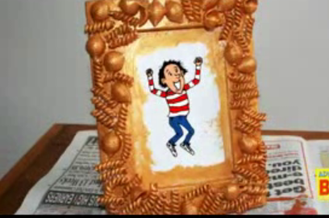  Activity 3  The Queen has received a new photograph of her great-grandchildren. Make a photo frame for Her Majesty to keep the photo in. You could use pasta and paint. |  | 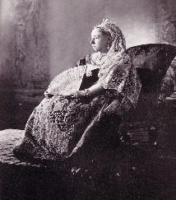  Activity 4  Safely use the internet to find a picture of a Queen from the past. Draw a portrait of Her. | 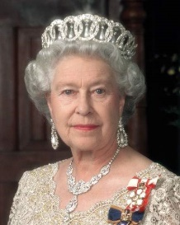  Activity 5  Create an information book about The Queen, using all of your learning from Summer term.
Date Completed
Home Comments

